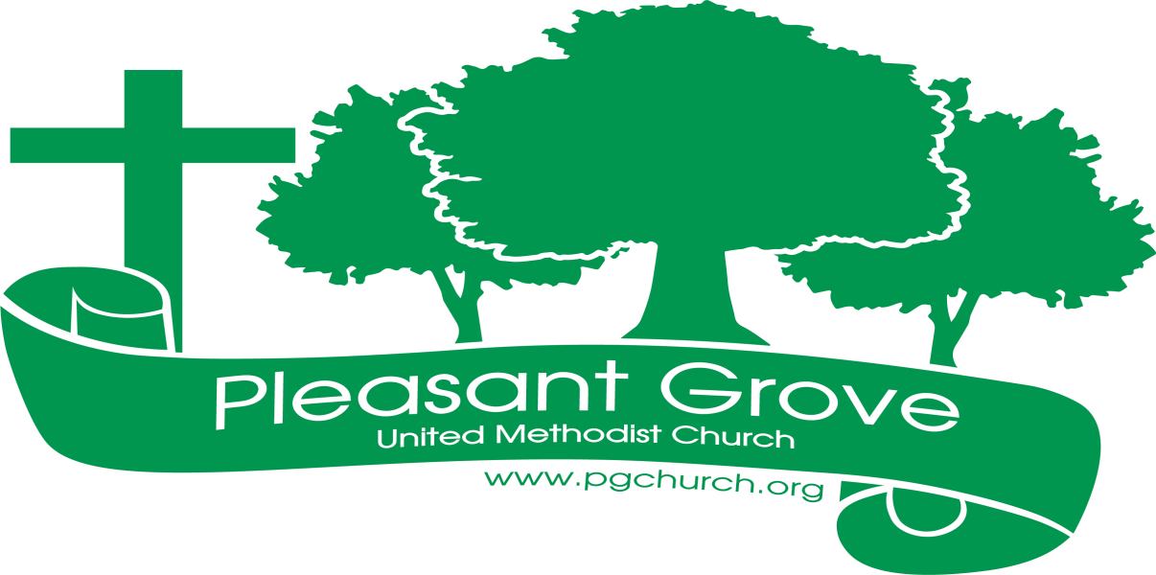
October 2026
Sharing the love of God through Jesus Christ

Silent Auction October 4-25, 2026

The Women of the Grove will hold a silent auction each Sunday in October. Two tables will be set up in the narthex along with the baskets and bid sheets. The Winner will be announced at the Chili Cook-off.
This fundraiser is to help support the ministries of our Women’s group. Over the past year the Women of the Grove have helped with the following:
- Delivered Christmas baskets to our homebound members.
- Helped with meals in times of bereavement.
- Supported church wide meals, stocked the supplies in the fellowship hall.
- At the beginning of this school year the ladies purchased backpacks and school supplies for the children at Sawnee Elementary who did not have supplies.
- The women sent a donation to UMCOR last spring to help with the needs utilized by the United Methodist Committee on Relief.
If you would like to donate to the Women of the Grove to help us with the ministries for 2027, please contact our treasurer, Amy Faulkenberry.

Fall Chili Cook-off October 25,2026

The Women of the Grove will sponsor this year’s annual Chili cook off. A sign-up sheet is in the narthex for the meal. This is always a wonderful time of fellowship in our church as we all enjoy sampling each other’s chili recipes. Who will win this year?
The Walraven’s are organizing our fall hayride which will begin at 5:00 pm. Our meal will follow around 6:00 pm. Please mark your calendars now for our fall event and dinner.

Remember the book study on Wednesday evenings at 6:30.
Charge Conference will be October 11 at 4:30 pm.


Join us for coffee and conversation in the Welcome Center before and after worship. Sign-up sheet is in the narthex to prepare the coffee and bring sweets.
***************************************************************************************************************
If you would like to place flowers in memory or in honor of someone, the sign-up is in the narthex. Please no artificial flowers.
*************************************************************************************************
Altar Guild for October – Kim Fannin &
**************************************************************************************************
If you have a prayer request or an announcement, contact Diane or Rev. Meg.
Or email pgumc30028@gmail.com These are sent out weekly on Wednesday.
***************************************************************************************************

Worship Servants

Greeters/ Ushers Liturgist
October 4- Gavin & Darlene Delaney October 4- Chris Bannon
October 11-Tammy Mc Grady & October 11- Diane Gilbert
October 18- Amy Faulkenberry & Jane Martin October 18 – David Martin
October 25- Wesley Walraven & David Smith October 25- Kim Fannin

Birthdays

October 5- Kathlyn Grella October 18- Kurt Ross
October 8- Terra Manton October 19- Terry Blalock
October 11- Will Sacca October 20- Mariella Sacca
October 13- Linda Walraven October 21- Gavin Delaney
October 17- Kim Fannin October 24- Emily Garmon

Anniversaries
October 17- Joe & Dawn Grella
October 27- Chris & Gail Bannon
October 28- Richard & Brenda Ashmore

October
Sun. | Mon. | Tue. | Wed. | Thu. | Fri. | Sat.
Sunday | Monday | Tuesday | Wednesday | Thursday | Friday | Saturday
 |  |  |  | 1 | 2 | 3  Sewing Group
4  9:30- Choir  10:30- Worship | 5 | 6 | 7  6:30- Book Study | 8 | 9 | 10
11 | 12 | 13 | 14 | 15 | 16 | 17
9:30- Choir  10:30- Worship  4:30-Charge  Conference |  |  | 6:30- Book Study
18 | 19 | 20 | 21 | 22 | 23 | 24
9:30- Choir  10:30- Worship | 12-Women of the Grove |  | 6:30- Book Study
25 | 26 | 27 | 28 | 29 | 30 | 31
9:30-Choir  10:30-Worship  5-Chili Cook off/ hayride |  |  | 6:30- Book Study

