
September 2025
Sharing the love of God through Jesus Christ

Service at Lake Lanier in August
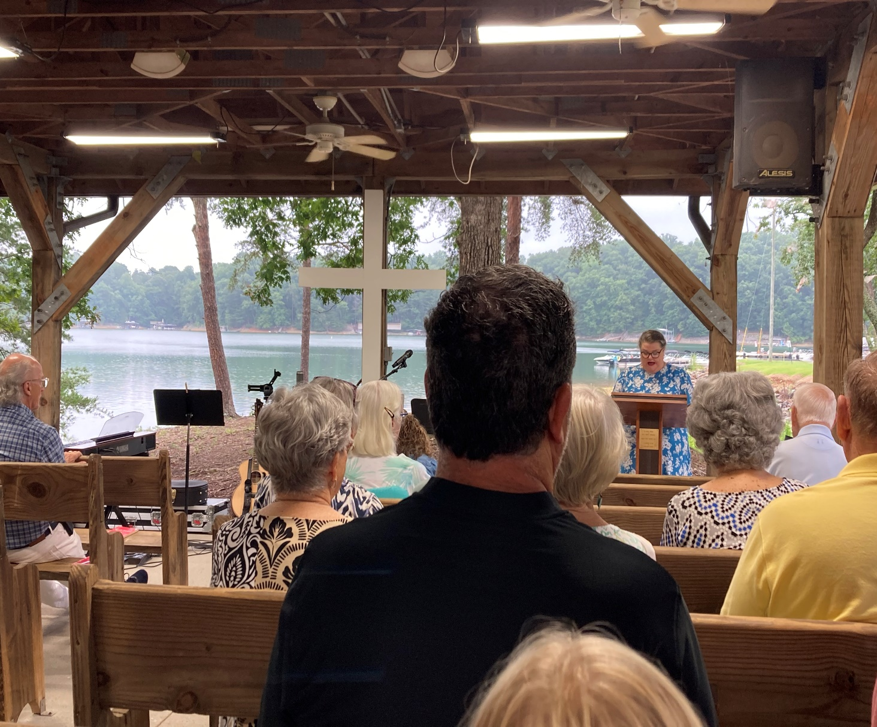


Join us for coffee and conversation in the Welcome Center before and after worship. Sign-up sheet is in the narthex to prepare the coffee and bring sweets.
***************************************************************************************************************
If you would like to place flowers in memory or in honor of someone, the sign-up is in the narthex. Please no artificial flowers.
*************************************************************************************************
Altar Guild for September – Luna Farris & Diane Gilbert
**************************************************************************************************
If you have a prayer request or an announcement, contact Diane or Rev. Meg.
Or email pgumc30028@gmail.com These are sent out weekly on Wednesday.
***************************************************************************************************

Worship Servants

Greeters/ Ushers Liturgist
September 6- Amy Faulkenberry & Jane Martin Chris Bannon
September 13- Richard & Brenda Ashmore David Martin
September 20- Kim Fannin & Kelley Fannin Diane Gilbert
September 27- Dennis Holbrookl & Terry Holbrook Kim Fanni

September

September 1- Josh Sacca September 25- Ashlyn McGrady
September 6- Mary Jones September 27-Seth Scott,
September 9- Rex Tallant Pat Ripley
September 13- David Bradley September 29- Brenda Ashmore
September 21- Jean Massie September 30- Sandy Putnam

Anniversaries
September 10- Don & Sandi Putnam
September 12- Kurt & Valerie Ross
September 15- David & Jennifer Wisniewski
September 27 – Pat & Cindi Ripley

Book Study

Our Fall Book Study will be Jesus is Lord: Living in the Lordship of Christ by Tom Berlin. Our first meeting will be September 16 at 6:30pm. If you would like to order a book please let Diane know by September 6.

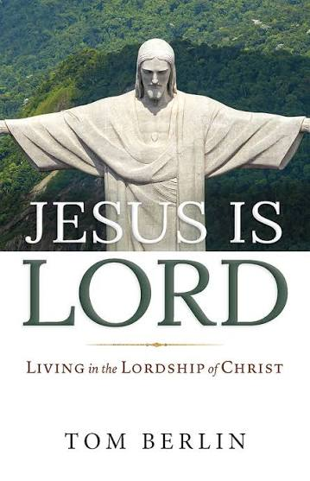

September
Sun. | Mon. | Tue. | Wed. | Thu. | Fri. | Sat.
Sunday | Monday | Tuesday | Wednesday | Thursday | Friday | Saturday
 |  | 1 | 2 | 3 | 4 | 5
6  9:30- Choir  10:30- Worship | 7 | 8 | 9 | 10 | 11 | 12
13 | 14 | 15 | 16 | 17 | 18 | 19
9:30- Choir  10:30- Worship  4-Church  Council |  |  | 6:30- Book Study
20 | 21 | 22 | 23 | 24 | 25 | 26
9:30- Choir  10:30- Worship | 12-Women of the Grove |  | 6:30- Book Study
27 | 28 | 29 | 30
9:30-Choir  10:30-Worship |  |  | 6:30- Book Study
31

