

May 2026
Sharing the love of God through Jesus Christ

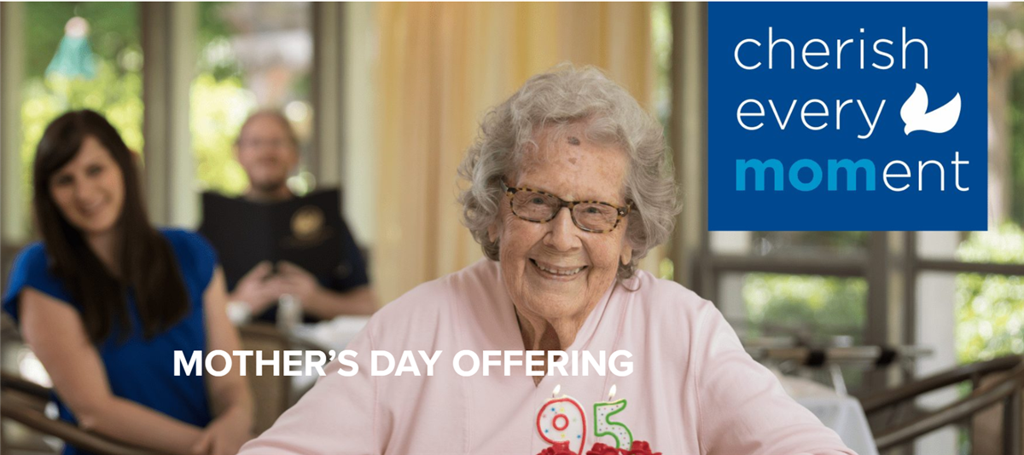
The Wesley Woods Mother’s Day Offering provides charitable financial assistance, pastoral care, and wellness programming to older adults living in Wesley Woods communities. Support is provided to residents in need of financial assistance to remain in their Wesley Woods homes. A robust wellness program includes fitness classes and on-site nurses to enhance the well-being of residents, enabling them to live independently longer. Wesley Woods chaplains provide ministry through personal visits, pastoral support, Bible study, and worship. Help create hope and spread joy with a gift to Wesley Woods. You may give online at wesleywoods.org/donate or scan the QR code. Thank you for helping to ensure seniors living at Wesley Woods continue to thrive.

Prayer Line

If you have a prayer concern or request, let me know by Wednesday of each week. I am starting the Prayer Concern e-mail and adding them to the Newsletter up again. Diane
Please keep these folks in your prayers.
Terra Manton John & Amy Faulkenberry
Anita & Joe Knight Cindi Ripley
The Martins’ and their parents Richard & Brenda Ashmore
Terry & Beth Blalock

*******************************************************************************************************************

March Worship Servants
Greeters/ Ushers Liturgist
May 3- Wesley Walaraven & David Smith David Martin
May 10 – Richard & Brenda Ashmore Josh Sacca
May 17- Amy Faulkenberry & Jane Martin David Martin
May 24- Tammy McGrady & Seth Steinberg Diane Gilbert
May 31 – Bob & Jamie Grimsley Kim Fannin


May- 13- Jennifer Sacca May 25- Shawn Ellis
May 14- Emma McMiillan May 28- Cheryl Wilder
May 18- Jason Murphy May 29 – Lauren Ripley
May 19- Katie Wallace May 32 – Allison Ellis
May 21- Cameron Wisniewski
May 23- Dianna Trible



.

This Photo by Unknown Author is licensed under CC BY-NC
If You would like to place flowers in the sanctuary in honor of or in Memory there is a list is in the narthex. Please no artificial flowers.

**************************************************************************************************

Join us for coffee and conversation in the Welcome Center before and after worship. Sign-up sheet is in the narthex to prepare the coffee and bring sweets
\

May
Sunday | Monday | Tuesday | Wednesday | Thursday | Friday | Saturday
Worship- 10-:30  Liturgist- |  | 6:30-Choir |  |  | 1 | 2
3 | 4 | 5 | 6 | 7 | 8 | 9
10:30- Worship-  Liturgist-  David Martin |  | 6:30-Choir
10 | 11 | 12 | 13 | 14 | 15 | 16
10:30- Worship  Liturgist-  Josh Sacca |  | 6:30-Choir
17 | 18 | 19 | 20 | 21 | 22 | 23
10:30- Worship  Liturgist-  David Martin |  | 6:30-Choir
24 | 25 | 26 | 27 | 28 | 29 | 30
10:30- Worship  Liturgist-  Diane Gilbert |  | 6:30-Choir
31
10:30- Worship

Liturgist:
Kim Fannin

