
January 2026
Sharing the love of God through Jesus Christ

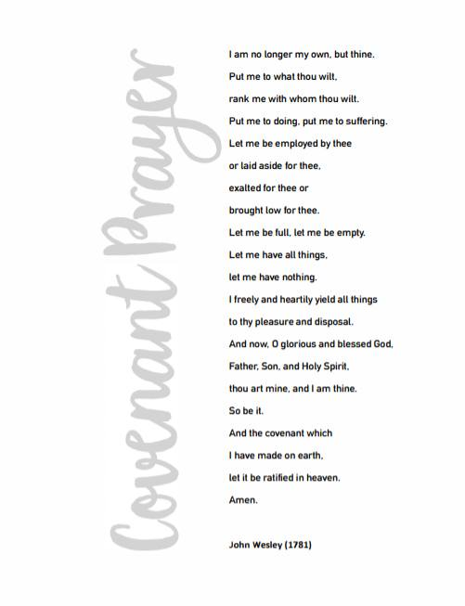


Prayer Line
Is anyone among you in trouble? Let them pray. Is anyone happy? Let them sing songs of praise. Is anyone among you sick? Let them call the elders of the church to pray over them and anoint them with oil in the name of the Lord. James 5:13-14
If you have a need for special prayer, please call or text Jennifer Wisniewski at 404-226-0023. If you would like to be
on the prayer chain call Jennifer or the Church Office (770- 844-7095) and your name will be added to the list.
Calling Post, who sends out our prayer line messages, has recently changed the phone numbers the calls are being sent from. If you have any kind of call screening or blocking on your phone and you are having trouble getting prayer line messages, please add the following as safe numbers (405) 669-
9959, (405) 669-9890 and (405) 669-9887.

If you have a prayer concern or request, let me know by Wednesday of each week. I am starting the Prayer Concern e-mail up again. Diane
Please keep these folks in your prayers.
Gwen “GG” Mc Cormick
Terra Manton
Anita & Joe Knight
Dennis Holbrook
The Martins’s and their parents
Darlene Delaney

*******************************************************************************************************************


Join us for coffee and conversation in the Welcome Center before and after worship. Sign-up sheet is in the narthex to prepare the coffee and bring sweets

January Worship Servants
Greeters/ Ushers Liturgist
January 4- Richard & Brenda Ashmore Kim Fannin
January 11- Kim Fannin & Kelly Fannin Chris Bannon
January 18- Steve Massie & Terry Holbrook Don Putnam
January 25 – David Smith & Wesley Walraven Josh Sacca

January 10- Ruth Holbrook
January 14 – Meridith Martin, Jennifer Wisniewski
January 15- Wesley Walraven
January 20- Isabella Sacca
January 22- Janie Holbrook



***************************************
If you would like to place flowers in memory or in honor of someone, the sign-up sheet is in the narthex. Please no artificial flowers.
************************************************************************************

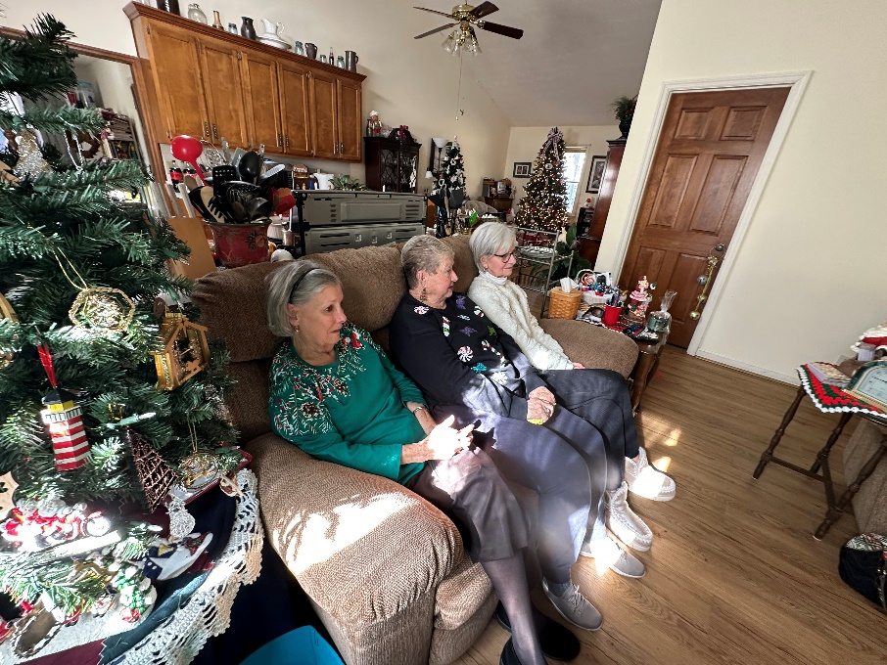

Photos from the Women’s Christmas Party at Diane Gilbert’s House.

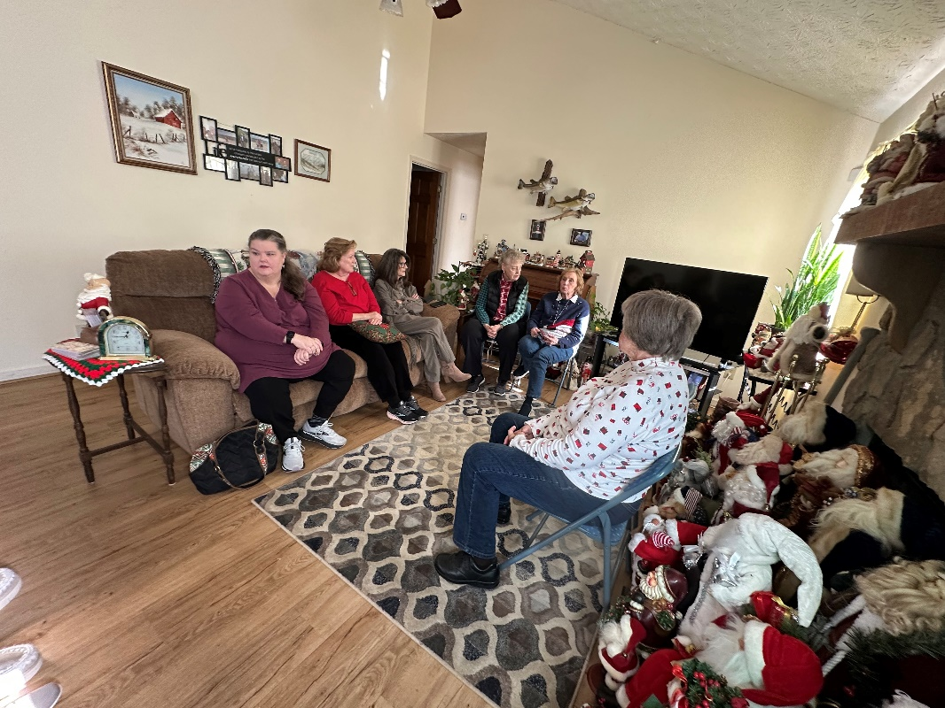



January
Sun. | Mon. | Tue. | Wed. | Thu. | Fri.
Sunday | Monday | Tuesday | Wednesday | Thursday |  | Friday | Saturday
 |  | 6:30-Choir |  | 1 |  | 2 | 3
4 | 5 | 6 | 7 | 8 |  | 9 | 11
10:30- Worship- |  | 6:30-Choir
11 | 12 | 13 | 14 | 15 |  | 16 | 17
10:30- Worship |  | 6:30-Choir
18 | 19 | 20 | 21 | 22 |  | 23 | 24
10:30- Worship | 12:30- Women of the Grove | 6:30-Choir |  |  |  |  | 9-12--Church Leadership
25 | 26 | 27 | 28 | 29 |  | 30 | 31
10:30- Worship |  | 6:30-Choir

