
February 2026
Sharing the love of God through Jesus Christ

During Lent this year we will have church wide focus on the book, Lent in Plain Sight, a devotion through ten objects by Jill Duffield. We will be meeting to discuss the book each week on Wednesday evening at 6:30pm as well as using it during worship.

Our Objects for each week are:
Wednesday, February 18- Dust
Wednesday, February 25- Bread
Wednesday, March 4- Cross
Wednesday, March 11- Coins
Wednesday, March 18- Shoes
Wednesday, March 25- Oil
Wednesday, April 1- Coats, Towels, Thorns

If you would like to order a book, please let Diane know by February 8. The books are $12.


Bonnie McMillan’s Celebration of Life Service
Pleasant Grove UMC
Saturday, February 28 1:00-3:00 pm

A Celebration of Life Service is planned for Bonnie McMillan on Saturday,
February 28, from 1:00 to 3:00 pm. The service will be held in the church at 1:00 pm
with a reception afterwards in the Fellowship Hall.
Bonnie’s family has asked everyone to wear bright colors.
There will be a time in the service for anyone to share a memory about Bonnie.
Loving Hands will be coordinating the receptio

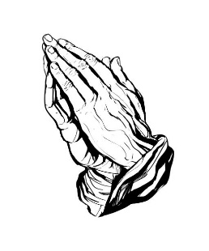
Prayer Line
Is anyone among you in trouble? Let them pray. Is anyone happy? Let them sing songs of praise. Is anyone among you sick? Let them call the elders of the church to pray over them and anoint them with oil in the name of the Lord. James 5:13-14
If you have a need for special prayer, please call or text Jennifer Wisniewski at 404-226-0023. If you would like to be on the prayer chain call Jennifer or the Church Office (770- 844-7095) and your name will be added to the list.
Calling Post, who sends out our prayer line messages, has recently changed the phone numbers the calls are being sent from. If you have any kind of call screening or blocking on your phone and you are having trouble getting prayer line messages, please add the following as safe numbers (405) 669-
9959, (405) 669-9890 and (405) 669-9887.

If you have a prayer concern or request, let me know by Wednesday of each week. I am starting the Prayer Concern e-mail up again. Diane
Please keep these folks in your prayers.
Elizabeth Pratt
Terra Manton
Gwen “GG” Mc Cormick
Anita & Joe Knight
Dennis Holbrook
The Martins’s and their parents
Darlene Delaney

*******************************************************************************************************************

February Worship Servants
Greeters/ Ushers Liturgist
February 1- Amy Faulkenberry & Jane Martin David Martin
February 8- Tammy McGrady & Seth Steinberg Diane Gilbert
February 15- Ruth Holbrok & Terra Manton Kim Fannin
February 22- Richard & Brenda Ashmore Don Putnam


February 7- Paige & Lucas Restrepo
February 8- Zoe Scott
February 10 – Morris Williams & Kim Krier
February 18- Paul Cheatham
February 19- Amy Murphy
February 25- Jamie Grimsley
February 27- Kelley Tribble & Katrina Restrepo



February 11- Rex And Denise Tallant
February 20- Gavin & Darlene Delaney
Jason & Amy Murphy
February 21- Bob & Jamie Grimsley
February 24- David & Jane Martin

.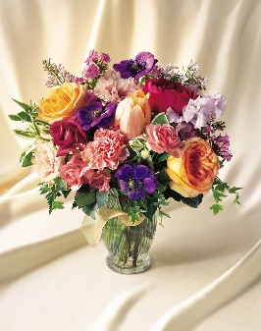
This Photo by Unknown Author is licensed under CC BY-NC
If You would like to place flowers in the sanctuary in honor of or in Memory there is a list is in the narthex. Please no artificial flowers.

**************************************************************************************************



Join us for coffee and conversation in the Welcome Center before and after worship. Sign-up sheet is in the narthex to prepare the coffee and bring sweets

February
Sunday | Monday | Tuesday | Wednesday | Thursday | Friday | Saturday
1  Worship- 10-:30  Liturgist- David Martin | 2 | 3  11- Women of the Grove  6:30-Choir | 4 | 5 | 6 | 7
8 | 9 | 10 | 11 | 12 | 13 | 14
10:30- Worship-  Liturgist- Diane Gilbert |  | 6:30-Choir
15 | 16 | 17 | 18 | 19 | 20 | 21
10:30- Worship  Liturgist-  Kim Fannin | 12:30 – Women of the Grove | 6:30-Choir | 6:30-Ash Wednesday  Lenten Study
22 | 23 | 24 | 25 | 26 | 27 | 28
10:30- Worship  Liturgist-  Chris Bannon |  | 6:30-Choir | 6:30-Lenten Study |  |  | 3- Celebration of Life- Bonnie McMillan
March 1 | 2 | 2 | 2 | 9
10:30- Worship  Liturgist-  Don Putnam |  | 6:30-Choir | 6:30-Lenten Study

