
November 2025
Sharing the love of God through Jesus Christ

As the year rolls around to November again, I like to remember
what makes me thankful…
- My Parents, Pat and Dianne
- My Brothers, David, Andrew, and Ben
- My Sister-in-laws, Sara and Lauren
- My nieces, Ava, Grace and Lucy
- My nephews, Jack and Sam
- Lifelong friends, Jen and Suzanne
- My colleagues and Friends, Emily, Anjie and Blair
- My ACE group, The Care Bears, Lindsay, Brent, Andi, Jennifer and Brian
- The parsonage that provides a roof over my head
- My health even when I am reminded that it is not perfect
- The care provided by Doctors and health professionals
- Chocolate chip cookies
- The smell of a match being lit (and candles too)
- Wordle and connections every morning and winning at Wordle Golf
- My extended family group chat
- The Georgia Bulldawgs
- The Academy for Spiritual Formation family
- Creek Hike at Camp Glisson
- Cool temperatures at night
- Sourdough bread toasted with butter
- A good chocolate milkshake
- The thrill of new gymnastics season – Go Gymdawgs!
- The new Trader Joes
- Quiet days at the beach
- My emotional support Kindle and all the books
- My colleagues in the NGUMC and my soon to be colleagues in South GA
- My District Superintendent, Doug
- The Staff of PGUMC, Diane, David, and Kye Ha
- The Leadership of PGUMC
- The whole church family of PGUMC
I am so grateful to God for all the ways I reminded of God presence with me and All the ways I see God in the world. What are you thankful for?
Peace and Grace,
Meg

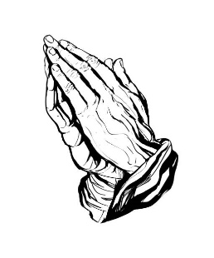
Prayer Line
Is anyone among you in trouble? Let them pray. Is anyone happy? Let them sing songs of praise. Is anyone among you sick? Let them call the elders of the church to pray over them and anoint them with oil in the name of the Lord. James 5:13-14
If you have a need for special prayer, please call or text Jennifer Wisniewski at 404-226-0023. If you would like to be
on the prayer chain call Jennifer or the Church Office (770- 844-7095) and your name will be added to the list.
Calling Post, who sends out our prayer line messages, has recently changed the phone numbers the calls are being sent from. If you have any kind of call screening or blocking on your phone and you are having trouble getting prayer line messages, please add the following as safe numbers (405) 669-
9959, (405) 669-9890 and (405) 669-9887.
If you have a prayer concern or request, let me know by Wednesday of each week. I am starting the Prayer Concern e-mail up again. Diane


Join us for coffee and conversation in the Welcome Center before and after worship. Sign-up sheet is in the narthex to prepare the coffee and bring sweets.
***************************************************************************************************************

November Worship Servants
Greeters/ Ushers Liturgist
November 2- Richard & Brenda Ashmore Don Putnam
November 9- Kim Fannin & Kelley Fannin David Martin
November 16 – Steve Massie & Terry Holbrook Diane Gilbert
November 23- David Smith & Wesley Walraven Mary Cheatham
November 30 – Amy Faulkenberry & Jane Martin Kim Fannin

November 1- Ben Tribble November 26- Devin Ripley
November 6- Luis Restrepo November 27 – Chris Bannon
November 20- Kaitlyn Grella November 30- Kelly Fannin
November 24 – Michael Dye


November 9- John & Sarunya Dye
November 21 – Joe & Anita Knight

***************************************
If you would like to place flowers in memory or in honor of someone, the sign-up sheet is in the narthex. Please no artificial flowers.
************************************************************************************

Coats, Coats, Coats of any size

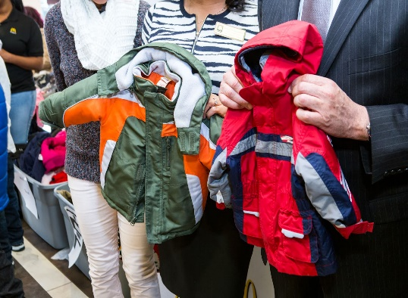

Do you have coats that are cluttering up your closet? Now is the time to bring them to the clubhouse. We will be donating the coats to the needy.

*******************************************************************************************************************

Chili Cook-off Fun for All

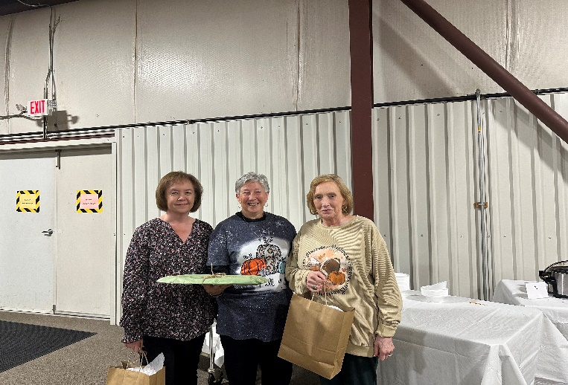

1st place – Linda Walraven, 2nd place – Diane Gilbert, 3rd place- Tammy McGrady
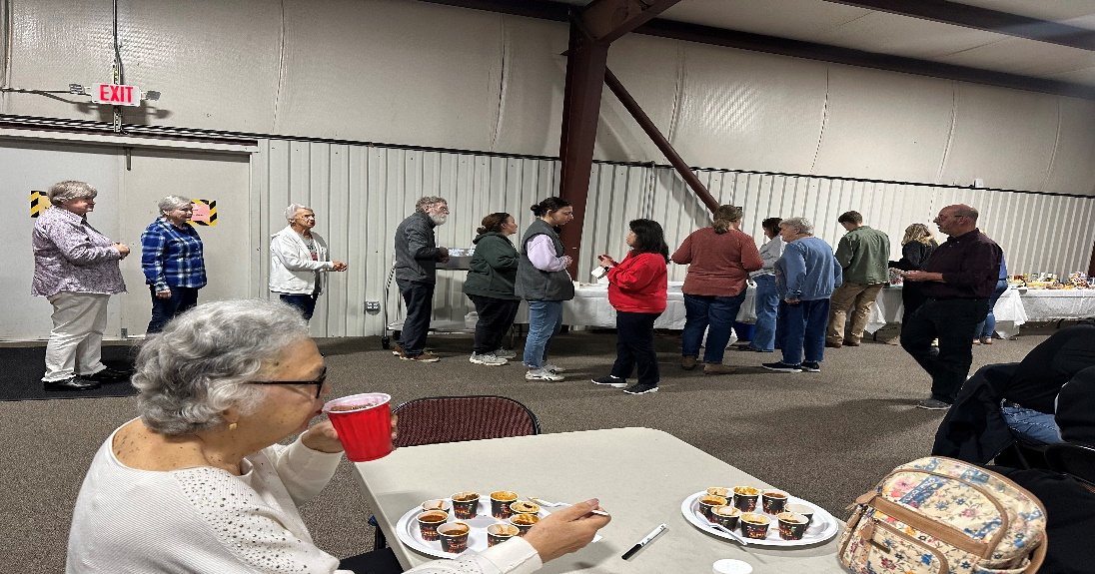

 November
This Photo by Unknown Author is licensed under CC BY-NC
Sun. | Mon. | Tue. | Wed. |  | Thu. | Fri. | Sat.
Sunday | Monday | Tuesday | Wednesday |  | Thursday | Friday | Saturday
 |  | 7-Choir |  |  |  |  | 1
2 | 3 | 4 |  | 5 | 6 | 7 | 8
10:30- Worship |  | 7-Choir
9 | 10 | 11 |  | 12 | 13 | 14 | 15
10:30- Worship  Charge conference |  | 7-Choir
16 | 17 | 18 |  | 19 | 20 | 21 | 22
10:30- Worship | 12:30- Women of the Grove | 7-Choir
23 | 24 | 25 |  | 26 | 27 | 28 | 29
10:30- Worship  Decorate for Christmas |  | 7-Choir |  |  | Happy  Thanksgiving!  
30
10:30 worship

