
December 2025
Sharing the love of God through Jesus Christ

Hope Love Joy Peace

Christmas at the Grove

Christmas luncheon December 7th following worship

Christmas Cantata December 14th during morning worship

Women of the Grove Luncheon December 15th 12:30pm

Open House at the parsonage December 21st 2-4pm

Christmas Eve Service December 24th 4pm




Prayer Line
Is anyone among you in trouble? Let them pray. Is anyone happy? Let them sing songs of praise. Is anyone among you sick? Let them call the elders of the church to pray over them and anoint them with oil in the name of the Lord. James 5:13-14
If you have a need for special prayer, please call or text Jennifer Wisniewski at 404-226-0023. If you would like to be
on the prayer chain call Jennifer or the Church Office (770- 844-7095) and your name will be added to the list.
Calling Post, who sends out our prayer line messages, has recently changed the phone numbers the calls are being sent from. If you have any kind of call screening or blocking on your phone and you are having trouble getting prayer line messages, please add the following as safe numbers (405) 669-
9959, (405) 669-9890 and (405) 669-9887.
If you have a prayer concern or request, let me know by Wednesday of each week. I am starting the Prayer Concern e-mail up again. Diane


Join us for coffee and conversation in the Welcome Center before and after worship. Sign-up sheet is in the narthex to prepare the coffee and bring sweets.
***************************************************************************************************************

November Worship Servants
Greeters/ Ushers Liturgist
December 7- Tammy Mc Grady & Seth Steinberg Chris Bannon
December 14 – Gavin & Darlene Delaney Amy Faulkenberry
December 21 – Steve Massie & Terry Holbrook Don Putnam
December 28 – Amy Faulkenberry & Jane Martin Diane Gilbert


December 9- Jason Murphy December 22- Byron Garmon December 13- Dennis Holbrok, Wanda Garmon December 26- Amy Faulkenberry December 14- Will Ross December 29- Kathy Holbrooks December 15- Sue Tribble Jane Martin December 16 – Tammy Mc Grady



December 9- Kelley & Dianna Tribble
December 18- Wesley & Linda Walraven

***************************************
If you would like to place flowers in memory or in honor of someone, the sign-up sheet is in the narthex. Please no artificial flowers.
************************************************************************************ 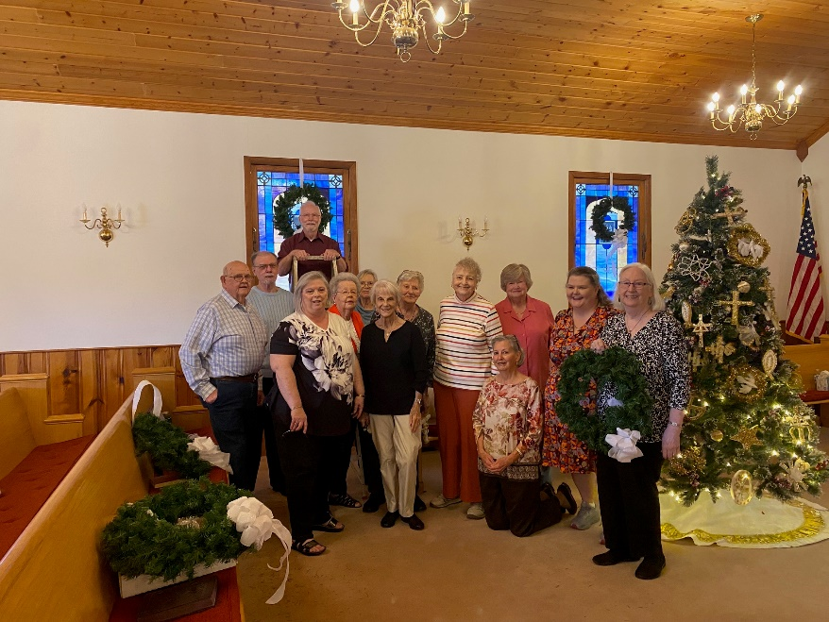 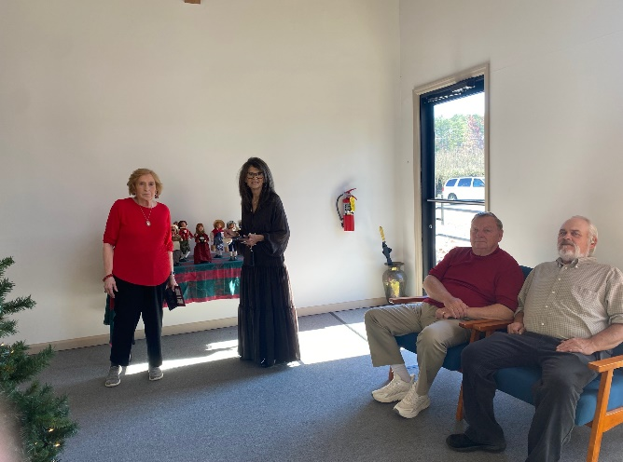
Decorating the Chrismon Tree

 December
This Photo by Unknown Author is licensed under CC BY-SA
Sun. | Mon. | Tue. | Wed. | Thu. | Fri.
Sunday | Monday | Tuesday | Wednesday | Thursday | Friday | Saturday
 | 1 | 2  6:30-Choir | 3 | 4 | 5 | 6
7 | 8 | 9 | 10 | 11 | 12 | 13
10:30- Worship- Church Luncheon |  | 6:30-Choir
14 | 15 | 16 | 17 | 18 | 19 | 20
10:30- Worship  Choir Cantata | 12:30- Women of the Grove at Diane Gilbert’s | 6:30-Choir
21 | 22 | 23 | 24 | 25 | 26 | 27
10:30- Worship  2-4- Open House at Parsonage |  | 6:30-Choir | 4-Christmas  Eve Service | 
28 | 29 | 30
10:30- Worship |  | 6:30-Choir

