October 2025

Sharing the love of God through Jesus Christ

**Remember there is Power in Prayer**

When you pray, God listens.

When you pray, storms get stilled.

When you pray, doors are opened.

When you pray, relationships get restored.

When you pray, sickness gets healed.

When you pray, strength is restored.

When you pray, answers will come

.

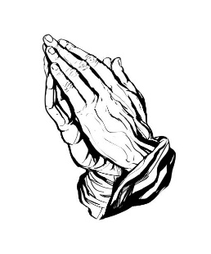 

Prayer Line

Is anyone among you in trouble? Let them pray. Is anyone happy? Let them sing songs of praise. Is anyone among you sick? Let them call the elders of the church to pray over them and anoint them with oil in the name of the Lord. James 5:13-14

If you have a need for special prayer, please call or text Jennifer Wisniewski at 404-226-0023. If you would like to be

on the prayer chain call Jennifer or the Church Office (770- 844-7095) and your name will be added to the list.

Calling Post, who sends out our prayer line messages, has recently changed the phone numbers the calls are being sent from. If you have any kind of call screening or blocking on your phone and you are having trouble getting prayer line messages, please add the following as safe numbers (405) 669-

9959, (405) 669-9890 and (405) 669-9887.

If you have a prayer concern or request, let me know by Wednesday of each week. I am starting the Prayer Concern e-mail up again. Diane



**Join us for coffee and conversation in the Welcome Center before and after worship.** Sign-up sheet is in the narthex to prepare the coffee and bring sweets.

***************************************************************************************************************

October Worship Servants

Greeters/ Ushers Liturgist

October 5 – David Smith & Wesley Walraven Kim Fannin

October 12 – Amy Faulkenberry & Jane Martin Paul Cheatham

October 19 – Tammy Mc Grady & Seth Steinberg Mary Cheatham

October 26 – Gavin & Darlene Delaney Josh Sacca



October 4 – Dorothy Cantrell October 17 – Kim Fannin

October 5 – Katlyn Grella October 18 – Kurt Ross

October 8 – Terra Manton October 19 – Terry Blalock

October 11 – Will Sacca October 20 - Mariella Sacca

October 12 – Barbara Olson October 21- Gavin Delaney

October 13- Linda Walraven October 24 – Emily Garmon



October 17- Joe & Dawn Grella

October 27- Chris & Gail Bannon

October 28 – Richard & Brenda Ashmore

***************************************

If you would like to place flowers in memory or in honor of someone, the sign-up sheet is in the narthex. Please no artificial flowers.

************************************************************************************

Coats, Coats, Coats of any size





Do you have coats that are cluttering up your closet? Now is the time to bring them to the clubhouse. We will be donating the coats to the needy.

*******************************************************************************************************************

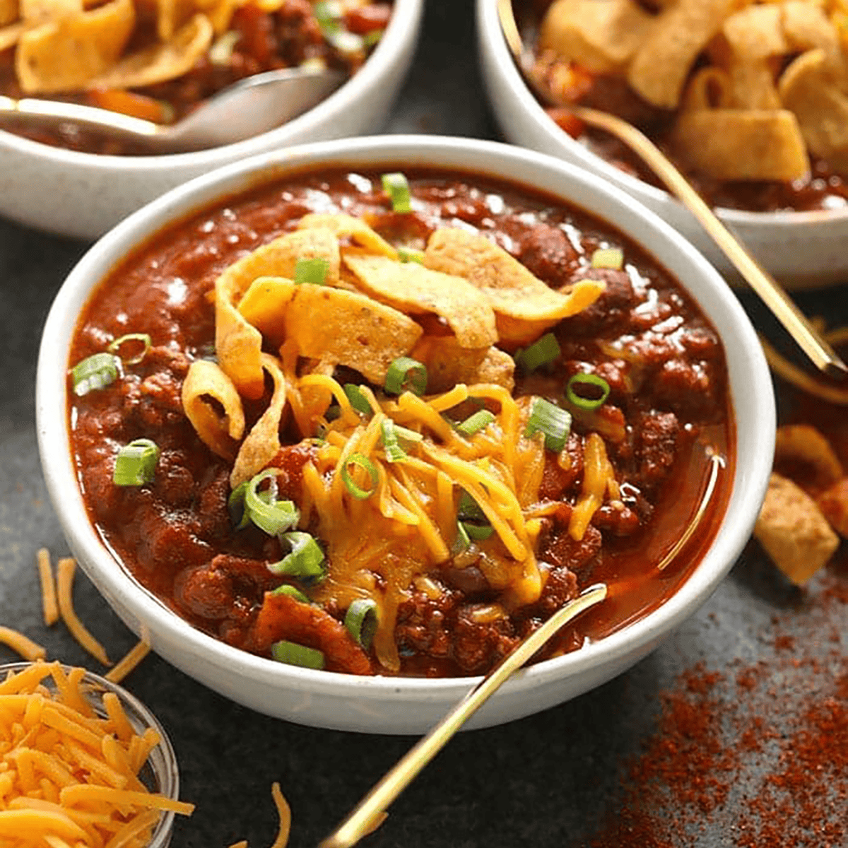

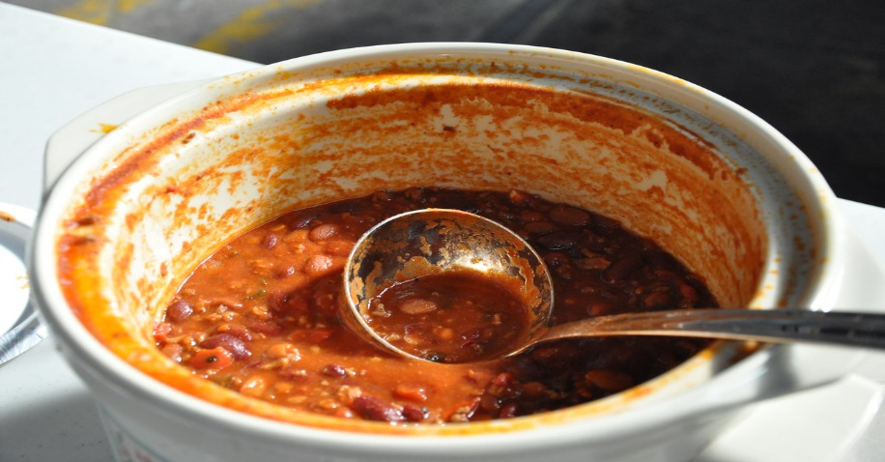

[This Photo](https://www.flickr.com/photos/lakemeadnra/8165162369/) by Unknown Author is licensed under [CC BY-SA](https://creativecommons.org/licenses/by-sa/3.0/)

Chili Cook-off

Get your chili ready for our annual chili cook-off and a hay ride October 26. We will taste and enjoy all the chili recipes. Come join us! Bring your chili and fellowship with us while we enjoy eating the chili.

October



[This Photo](https://freepngimg.com/png/35362-autumn-leaves-transparent-image) by Unknown Author is licensed under [CC BY-NC](https://creativecommons.org/licenses/by-nc/3.0/)

|  |  |  |  |  |  |  |  |
| --- | --- | --- | --- | --- | --- | --- | --- |
| Sun. | Mon. | Tue. | Wed. | | Thu. | Fri. | Sat. |
| Sunday | Monday | Tuesday | Wednesday | | Thursday | Friday | Saturday |
|  |  | 7-Choir | | 1  10:30 & 6:30  Bible Study | 2 | 3 | 4 |
| 5 | 6 | 7 | | 8 | 9 | 10 | 11 |
| 10:30- Worship |  | 7-Choir | | 10:30 & 6:30  Bible Study |  |  |  |
| 12 | 13 | 14 | | 15 | 16 | 17 | 18 |
| 10:30- Worship |  | 7-Choir | | 10:30 & 6:30  Bible Study |  |  |  |
| 19 | 20 | 21 | | 22 | 23 | 24 | 25 |
| 10:30- Worship | 12:30- Women of the Grove | 7-Choir | | 10:30 & 6:30  Bible Study |  |  |  |
| 26 | 27 | 28 | | 29 | 30 | 31 |  |
| 10:30- Worship  5- Hay Ride/ Chili Cook- off |  | 7-Choir | | 10:30 & 6:30 Bible Study |  |  |  |
|  |  |  | |  |  |  |  |