SEPTEMBER 2025

Sharing the love of God through Jesus Christ

Food for thought

Jesus died at 33. The human spine has 33 vertebrae. The same structure that holds us up is the same number of years He held this earth.

We have 12 ribs on each side. 12 disciples. 12 tribes of Israel. God built His design into our bones. He wrote Heaven into our anatomy.

The vagus nerve runs from your brain to your heart and gut. It calms storms inside the body. It looks just like a cross. That’s the power source running through us. Every time your body heals, every time your heart slows in prayer, every time peace shows up when it shouldn’t … that’s Him.

Jesus rose on the third day. Science tells us that when you fast for 3 days, your body starts regenerating. Old cells die. New ones are born. Healing begins. Your body literally resurrects itself. That’s not coincidence. That’s design.

And it keeps going.

Your heart has an electrical rhythm. Your brain lights up when you pray. Tears contain different chemicals depending on if you’re crying from joy or grief. The blood speaks. The bones store memory. The body worships whether you realize it or not.

We are fearfully and wonderfully made. We are walking prophecy. Walking tabernacles. Dust and divinity in one.

God didn’t just create you. He carved Himself into you.

You don’t need to look far to find Him. You just have to look inward. He’s been in the design since the beginning.

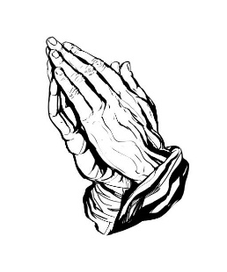 

Prayer Line

Is anyone among you in trouble? Let them pray. Is anyone happy? Let them sing songs of praise. Is anyone among you sick? Let them call the elders of the church to pray over them and anoint them with oil in the name of the Lord. James 5:13-14

If you have a need for special prayer, please call or text Jennifer Wisniewski at 404-226-0023. If you would like to be

on the prayer chain call Jennifer or the Church Office (770- 844-7095) and your name will be added to the list.

Calling Post, who sends out our prayer line messages, has recently changed the phone numbers the calls are being sent from. If you have any kind of call screening or blocking on your phone and you are having trouble getting prayer line messages, please add the following as safe numbers (405) 669-

9959, (405) 669-9890 and (405) 669-9887.

If you have a prayer concern or request, let me know by Wednesday of each week. I am starting the Prayer Concern e-mail up again.

Diane

***************************************************************************

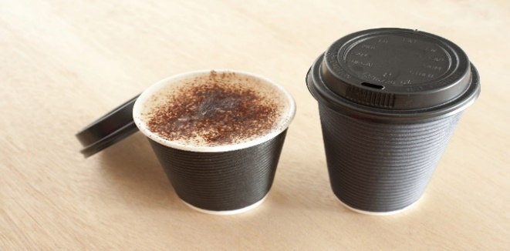

**Join us for coffee and conversation in the Welcome Center before and after worship.** Sign-up sheet is in the narthex to prepare the coffee and bring sweets.

***************************************************************************************************************

September Worship Servants

Greeters/ Ushers Liturgist

September 7 -Amy Faulkenberry & Jane Martin David Martin

September 14 – Richard & Brenda Ashmore Chris Bannon

September 21 – Kim Fannin & Kelley Fannin Diane Gilbert

September 28 – Steve Massie & Terry Holbrook Amy Faulkenberry



September 1- Josh Sacca September 28- Gene Mc Brayer

September 9- Rex Tallant September 29-Brenda Ashmore

September 10 Barbara Croft September 30- Sandy Putnam

September 13- David Bradley

September 21- Jean Massie

September 25- Ashlyn McGrady

September 27- Pat Ripley



September 10- Don & Sandy Putnam

September 15- David & Jennifer Wisniewski

September 27- Pat & Cindi Ripley

***************************************

If you would like to place flowers in memory or in honor of someone, the sign-up is in the narthex. Please no artificial flowers.

*************************************************************************************

September

|  |  |  |  |  |  |  |
| --- | --- | --- | --- | --- | --- | --- |
| Sun. | Mon. | Tue. | Wed. | Thu. | Fri. | Sat. |
|  |  |  |  |  |  |  |
|  | 1 | 2  7-Choir | 3 | 4 | 5 | 6 |
| 7 | 8 | 9 | 10 | 11 | 12 | 13 |
| 10:30- Worship |  | 7-Choir |  |  |  |  |
| 14 | 15 | 16 | 17 | 18 | 19 | 20 |
| 10:30- Worship |  | 7-Choir |  |  |  |  |
| 21 | 22 | 23 | 24 | 25 | 26 | 27 |
| 10:30- Worship | 12:30- Women of the Grove | 7-Choir |  |  |  |  |
| 28 | 29 | 30 |  |  |  |  |
| 10:30- Worship |  | 7-Choir |  |  |  |  |
|  |  |  |  |  |  |  |