 July 2025

Sharing the love of God through Jesus Christ

Summer is here! It is time for time at the pool or the lake, time for cookouts and vacations. The produce is amazing, and the grass is still green (thank you rain.) We have so many things to enjoy around us. God’s creation is on full display. It is a time to be grateful and time to witness the works of God’s hand.

As you eat that perfect tomato sandwich or take a cool dip or hear the laughter of gathered family, remember all the ways that God has cared for you. How you have been held by God for this moment. Being present in the moment that we are offered by this season, not concerning ourselves about all the other moments, just this one. Take time to appreciate each and every day, the sunrises and the sunsets. Give thanks to God for all of creation and our place in it.

Peace and Grace,

Meg



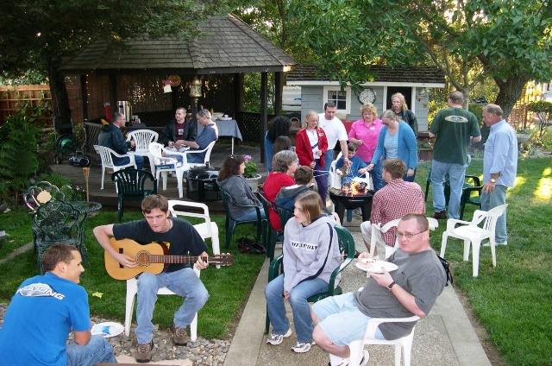

[This Photo](https://defeatdespair.com/2020/08/10/summer-afternoon-2/) by Unknown Author is licensed under [CC BY-SA](https://creativecommons.org/licenses/by-sa/3.0/)

 

Prayer Line

Is anyone among you in trouble? Let them pray. Is anyone happy? Let them sing songs of praise. Is anyone among you sick? Let them call the elders of the church to pray over them and anoint them with oil in the name of the Lord. James 5:13-14

If you have a need for special prayer, please call or text Jennifer Wisniewski at 404-226-0023. If you would like to be

on the prayer chain call Jennifer or the Church Office (770- 844-7095) and your name will be added to the list.

Calling Post, who sends out our prayer line messages, has recently changed the phone numbers the calls are being sent from. If you have any kind of call screening or blocking on your phone and you are having trouble getting prayer line messages, please add the following as safe numbers (405) 669-

9959, (405) 669-9890 and (405) 669-9887.

If you have a prayer concern or request, let me know by Wednesday of each week. I am starting the Prayer Concern e-mail up again.

Diane

***************************************************************************

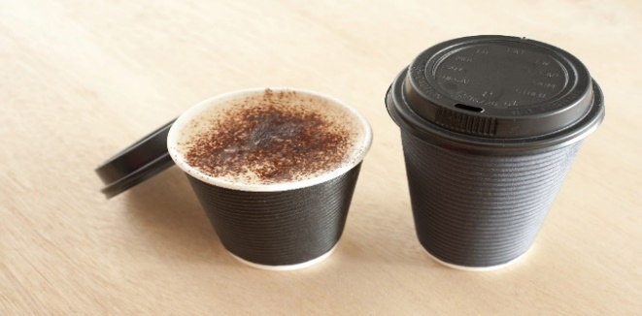

**Join us for coffee and conversation in the Welcome Center before and after worship.** Sign-up sheet is in the narthex to prepare the coffee and bring sweets.

***************************************************************************************************************

We will have a send-off luncheon on August 10th for Will as he begins another chapter of life at college.

Worship Servants

Greeters/ Ushers Liturgist

July 6 – Richard & Brenda Ashmore Mary Cheatham

July13- Morris Williams & Brandy Banks Amy Faulkenberry

July 20-Seth Steinberg & Tammy McGrady Kim Fannin

July 29- None needed No one



July

July 1- Mary Cheatham, Patience Wisniewski

July 3- David Wisniewski

July 15- Anita Knight

July 27- Debra Williams, Sara Mc Daniel

July 30- Wesley Ross

July 31- Rev. Meg



July 14- Steve & Jean Massie

***************************************

If you would like to place flowers in memory or in honor of someone, the sign-up is in the narthex. Please no artificial flowers.

*************************************************************************************

July

|  |  |  |  |  |  |  |
| --- | --- | --- | --- | --- | --- | --- |
| Sun. | Mon. | Tue. | Wed. | Thu. | Fri. | Sat. |
|  |  | 1 | 2 | 3 | 4 | 5 |
|  |  |  | 7-Choir |  | Happy Fourth  of July |  |
| 6 | 7 | 8 | 9 | 10 | 11 | 12 |
| 10:30- Worship |  |  | 7-Choir |  | 8- Holbrook Camp Meeting  begins |  |
| 13 | 14 | 15 | 16 | 17 | 18 | 19 |
| 10:30- Worship |  |  | 7-Choir |  |  |  |
| 20 | 21 | 22 | 23 | 24 | 25 | 26 |
| 10:30- Worship | 11:30- Work on Chrismon (FH) |  | 7-Choir |  |  |  |
| 27 | 28 | 29 | 30 | 31 |  |  |
| 9:00 Worship at Bald Ridge Chapel |  |  | 7-Choir |  |  |  |
|  |  |  |  |  |  |  |