January 2024

Sharing the love of God through
Jesus Christ

May God Bless Us in 2024

A New Year Prayer
We Pray...
For healing...prepare us for surprises.
For strength...prepare us for surprises.
For vision...prepare us for surprises.
For transformation...prepare us for surprises.
For messengers and messengers...prepare us for surprises.
For community...prepare us for surprises.
For acceptance - of ourselves and others...prepare us for surprises.
For making room at our tables...prepare us for surprises.
For Truth-seeking...prepare us for surprises.
For support...prepare us for surprises.
For Common Ground...prepare us for surprises.
Walk beside us, O Holy One,
as we question and welcome,
as we challenge and invite,
as we discover and understand,
as we see, touch, taste, smell, and listen for the Newness awaiting us…
May we, Your Holy People, walk forward together side by side.
Amen.
- Written by Sister Mary Ann Barret, O.P.
NEWS
Our merry choir sang Christmas carols for the folks at The Oaks on Post Rd. on Saturday, December 9th. The residents enjoyed the festive music and sang right along with us. What a blessing for all!

This Photo by Unknown Author is licensed under CC BY-NC-ND
Our Warmth in Winter mission project collecting hats, gloves, scarves and socks for the needy filled the Christmas Tree in the Welcome Center with 74 pairs of socks, 22 pairs of gloves, 16 caps and 9
scarves. Donations were given to The Place in Cumming.

Thank You for your many gifts, cards and treats over Christmas. Your love, thoughtfulness and generosity bless me beyond measure. With love, Pastor Dana

JANUARY AT PLEASANT GROVE

Women’s Bible Study resumes Tuesday morning, January 9 in the Club House.

Men’s Breakfast and the Bible: Saturday, January 20 at 9:00 a.m. in the Club House.

Soup and Cornbread Luncheon after worship, Sunday, January 21 in the Fellowship Hall. Sign up in the Welcome Center to bring your favorite soup, cornbread or a dessert to share.

Church Council Meeting, Sunday, January 21 at 5:00 p.m. in the Club House.

Women’s Group meets Monday, January 22 at 12:30 in the Club House.

COMING IN FEBRUARY

Ash Wednesday Service, February 14 at 7:00 p.m. in the Sanctuary.

Lenten Bible Study led by Pastor Dana. Study book, dates and times To Be Announced.
Prayer Line Is anyone among you in trouble? Let them pray. Is anyone happy? Let them sing songs of praise. 14 Is anyone among you sick? Let them call the elders of the church to pray over them and anoint them with oil in the name of the Lord. James 5:13-14
If you have a need for special prayer, please call or text Jennifer Wisniewski at 404-226-0023. If you would like to be on the prayer chain call Jennifer or the Church Office (770- 844-7095) and your name will be added to the list.
Calling Post, who sends out our prayer line messages, has recently changed the phone numbers the calls are being sent from. If you have any kind of call screening or blocking on your phone and you are having trouble getting prayer line messages, please add the following as safe numbers (405) 669-9959, (405) 669-9890 and (405) 669-9887.

Birthdays & Anniversaries and Worship Servants

Birthdays
January 5 - Pat Geld
January 10 - Ruth Holbrook
January 14 - Meredith Martin
Jennifer Wisniewski
January 15 - Wesley Walraven
January 20 - Isabella Sacca
January 22 - Janie Holbrook

Greeters/Ushers Liturgists

January 7 - Terry Holbrook & Steve Massie January 7- Kim Fannin
January 14 - Kim Fannin & Jane Martin January 14 - Amy Faulkenberry
January 21- Tammy McGrady & Seth Steinberg January 21- Don Putnam
January 28 - Morris Williams & Brandy Banks January 28 - Josh Sacca

Acolyte

January 7- Lucas Restrepo
January 14- Elijah Banks
January 21- Wendi Jones
January 28- Kim Fannin
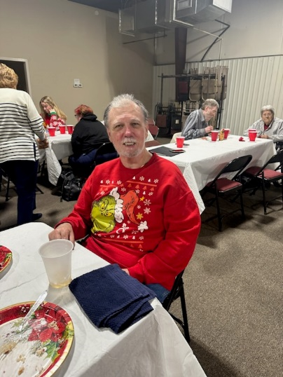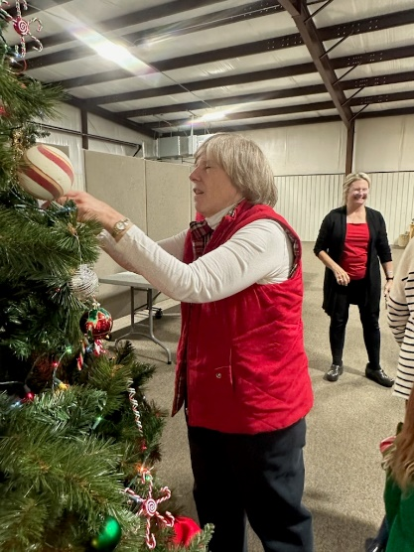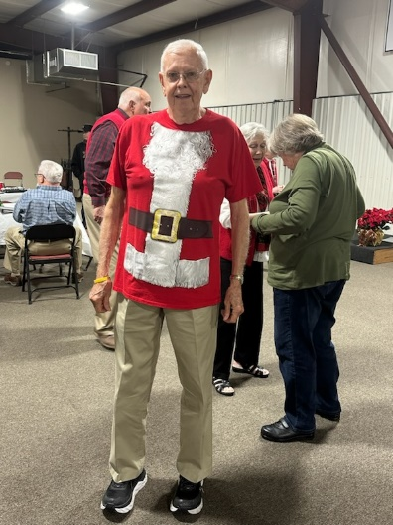
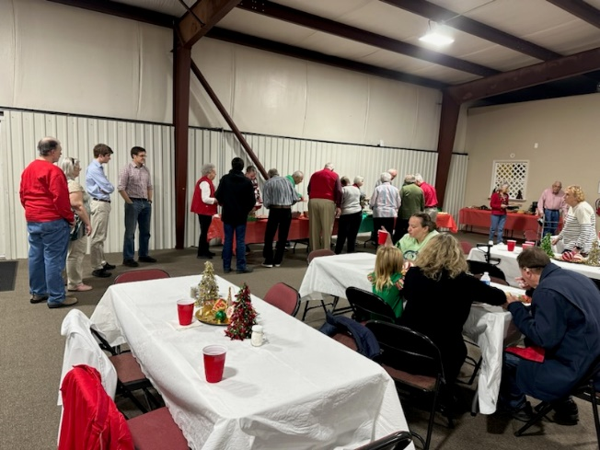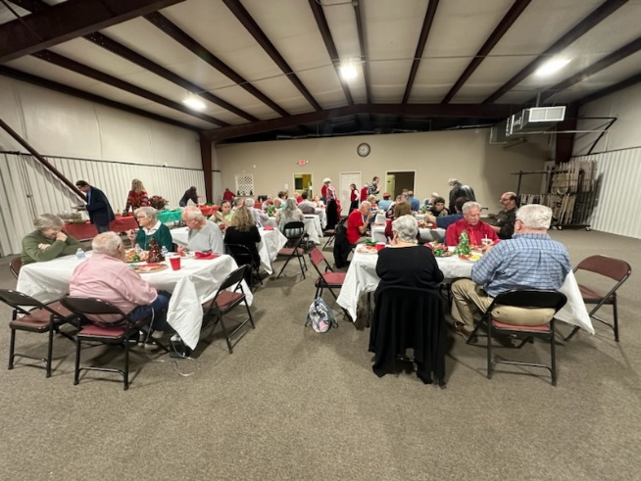

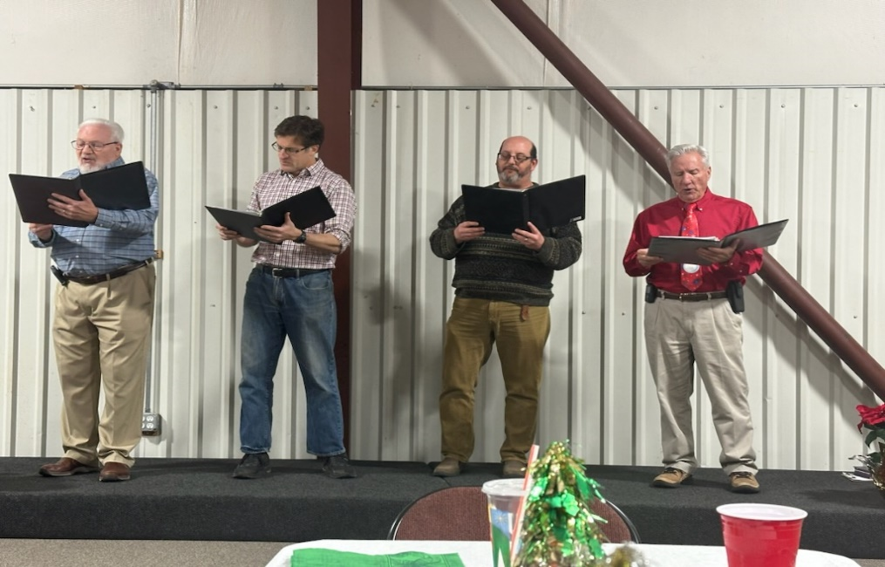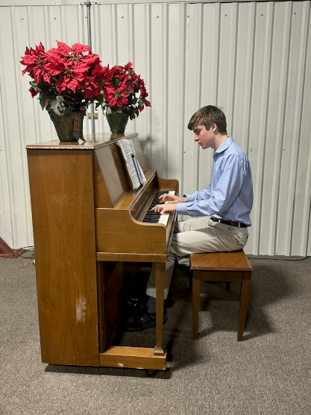
Food, Fun, Decorations and Music from a few of our Men

January
Sunday | Monday | Tuesday | Wednesday | Thursday | Friday | Saturday
33 |  | 10-Women’s Bible Study  6:30 Bible Study  6:30- Bible Study | 7-Choir | 9-1- Busy Bee Sewing Bee (CH) |  | 9-12- Church Work Day  9-12- Quilters
 | 1 | 2 | 3 | 4 | 5 | 6
10:30- Worship |  | 10-Women’s Bible Study (CH) | 6:30Choir | 9-1- Busy Bee Sewing Bee (CH)  7-9- Cumming Sunsetter Quilters (CH) |  | 9-12-Qilting (C)
7 | 8 | 9 | 10 | 11 | 12 | 13
10:30-Worship |  | 10-Women’s Bible Study (CH) | 6:30-Choir | 9-1- Busy Bee Sewing Bee (CH)  Quilters- 7 (CH)  Aintree HOA  7-9 (F)
14 | 15 | 16 | 17 | 18 | 19 | 20
10:30-Worship | 12:30-Women’s Group | 10-Women’s Bible Study (CH) | 6:30-Choir | 9-1- Busy Bee Sewing Bee (CH) |  | 9- Men’s Breakfast
21 | 22 | 23 | 24 | 25 | 26 | 27
10:30- Worship  Soup & Cornbread  Luncheon  5-Church Council  __________  28  10:30- Worship | -----------------  29 | 10-Women’s Bible Study (CH)  -------------------  30 | 6:30-Choir  -------------------  31 | 9-1 Busy Bee Sewing Be(CH)

