November 2023

Sharing the love of God through
Jesus Christ

NOVEMBER AT PLEASANT GROVE
Silent Auction Continues through November 12
The Silent Auction continues in the Welcome Center/Narthex. Stop by before after worship, check out the beautiful gift baskets and make your bids. Cash donations also gladly accepted. This is their fundraiser for the 2023-24 year. All money from the fundraiser goes directly to support the women’s ministry and missions. Last year’s projects included: Holiday Baskets to our Homebound, personal care kits and a donation sent with Terra to Honduras for medical needs.

Church Work Day, Saturday, November 4 9:00 a.m. – Noon
We have mostly outdoor projects, including trimming hedges, picking up branches and trash, blowing leaves and replacing some boards on the parsonage deck. We also need to straighten the pews and re-stock the Welcome Packets. Coffee and donuts will be ready for you when you arrive.

All Saints Sunday, November 5
We’ll remember the saints in our congregation who have passed away in the last year; also those among our family and friends.

The Generous Samaritan Worship Series
November 12, 19 and 26 in the sanctuary at 10:30 a.m. and online
What made the Good Samaritan so good? He loved God and neighbor by being generous with his heart, his time and his money.

Men’s Breakfast and the Bible, Saturday, November 18 at 9:00 a.m. in the Club House.
ANNOUNCEMENTS

THANK YOU from the bottom of my heart…
for your kind and generous gifts of Pastor Appreciation! I received cards, gift cards, homemade breads and a even a sheet cake to share, along with other goodies and gifts. I love and thank God for you all.
Pastor Dana

I would like to say A HUGE THANK YOU to everyone who made our annual Chili Cook-off a big success. Those of you who contributed food, and set-up the tables are so appreciated. Thank you, Diane for wearing many hats and making the signs, ballots and decorating, and helping me to remember everything! Thank you, Beth for getting the Basket of Love together for our wonderful pastor! And a big thank you to Wesley for providing a fun hayride. Thank all of you for your support and coming together for fellowship, great food and fun! - Amy Faulkenberry
WELCOME NEW MEMBERS! Bob and Jaimie Grimsley. We’re so glad to have you as a part of the Pleasant Grove family!

COFFEE SIGNUP Here is link to sign up to help out with making coffee and getting cookies/ doughnuts for after worship [fellowship time .signupgenius.com/go/4090448AEAC2FAB9-44572290-coffee#/

COMING FOR ADVENT/CHRISTMAS

THIS YEAR’S ADVENT/CHRISTMAS WORSHIP SERIES
The Gift of Being Present, designed by Marcia McFee. “Advent can be filled with worry about finding the perfect Christmas gifts. Deep down we want people in our lives to know they are special and we love them. But sometimes we overlook the greatest gift of all: our very presence.”
Join us each Sunday of Advent at 10:30 a.m. beginning December 3 as we prepare for Christmas through this very special worship series.

ADVENT STUDY
Faithful: Christmas Through the Eyes of Joseph
From his beginnings as a humble carpenter to his all-important role as the earthly father of Jesus Christ, Joseph’s place in the Nativity story is sometimes overlooked but contains valuable lessons for all of us. Join us in the Club House on Tuesday mornings at 10:00 or Tuesday evenings at 6:30, November 28, December 5, 12 and 19th. Order a book through Diane by Tuesday morning, November 14. Study book: $14.

CHRISTMAS BANQUET Sunday, December 3. Details coming soon.

CHRISTMAS EVE IS ON SUNDAY THIS YEAR! Join us at 10:30 a.m. for our Advent Service and/or at 5:00 p.m. for our Candle lighting Service.
Prayer Line Is anyone among you in trouble? Let them pray. Is anyone happy? Let them sing songs of praise. 14 Is anyone among you sick? Let them call the elders of the church to pray over them and anoint them with oil in the name of the Lord. James 5:13-14
If you have a need for special prayer, please call or text Jennifer Wisniewski at 404-226-0023. If you would like to be on the prayer chain call Jennifer or the Church Office (770- 844-7095) and your name will be added to the list.
Calling Post, who sends out our prayer line messages, has recently changed the phone numbers the calls are being sent from. If you have any kind of call screening or blocking on your phone and you are having trouble getting prayer line messages, please add the following as safe numbers (405) 669-9959, (405) 669-9890 and (405) 669-9887.

Pleasant Grove Women
Hope you are enjoying the fall season and weather. The women are planning on getting together Monday, November 13th at 10 am to bake cookies for the baskets we deliver to the Homebound and seniors of our church. If you make a good vegetable soup and have some to share, we will put it in the baskets along with the other goodies. Come join us!
We will be decorating the sanctuary and welcome center on November 27th at 10 am, join us as we prepare for the Christmas season.
November 13th 10 am in the Fellowship Hall November 27th at 10 am 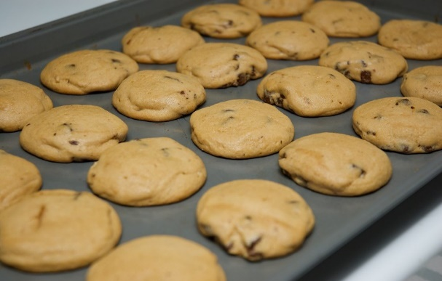 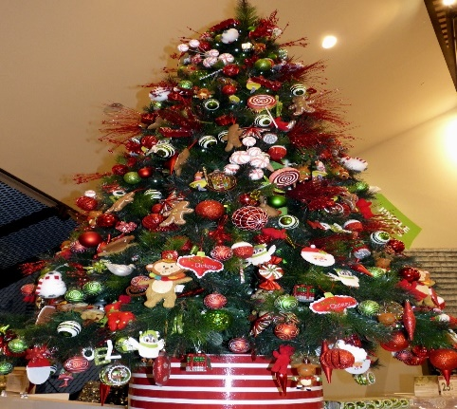
Bake Cookies Decorate for Christmas

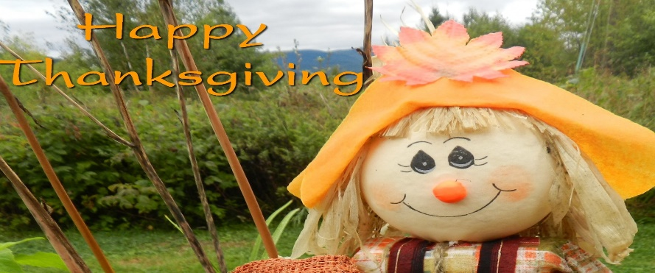

Birthdays & Anniversaries
Birthdays Anniversaries
November 1- Ben Tribble November 9 - John & Sarunya Dye
November 6 - Louis Restrepo November 21- Joe & Anita Knight
November 20 - Kaitlyn McGrady
November 24 - Michael Dye
November 26 - Devin Ripley November 27- Chris Bannon
November 30 - Kelly Fannin

Greeters/Ushers
November 5 - Gavin & Darlene Delaney
November 12 - Steve Massie & Terry Holbrook
November 19 - Kim Fannin & Ruth Holbrook
November 26 - Wesley Walraven & David Smith

Acolytes Liturgist
November 1- Marielle Sacca November 5 - Diane Gilbert
November 8 - Lucas Restrepo November 12- Gail Bannon
November 15 - Paige Restrepo November 19 - Don Putnam
November 22 - Kim Fannin November 26 - Chris Bannon
November 29 - Elijah Banks

Counters Altar Guild
Amy Faulkenberry Linda Walraven
Barbara McNutt Kim Fannin
Terra Manton

Chili Cook-off

If you missed the chili cook-off you missed a good time and good chili. Before the meal, Wesley took us on a hayride. Then on to the sampling of the chili. After samples were had, dessert was then enjoyed.

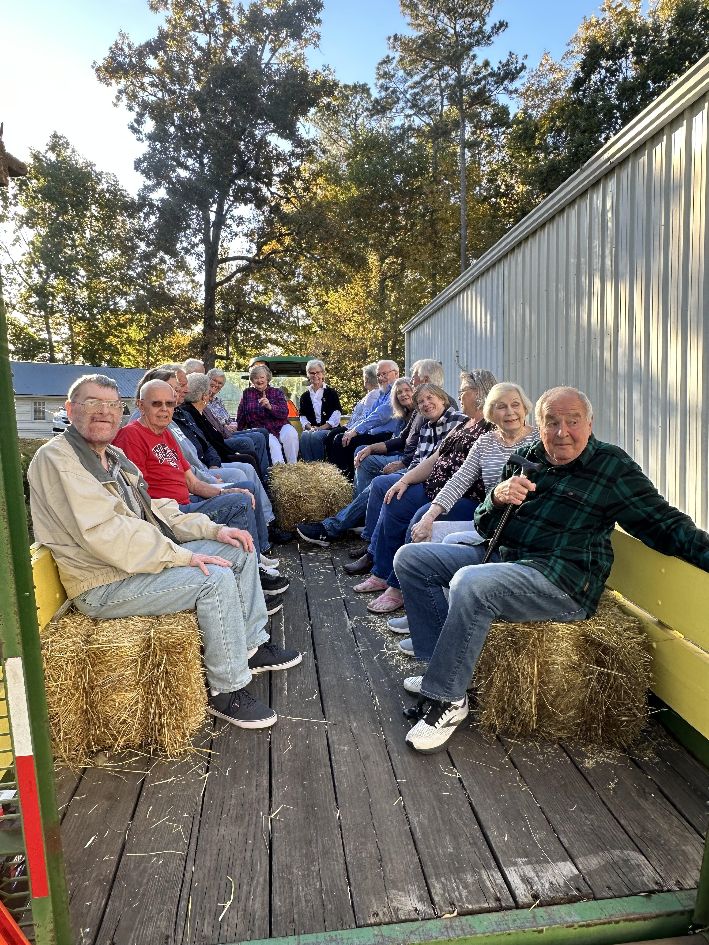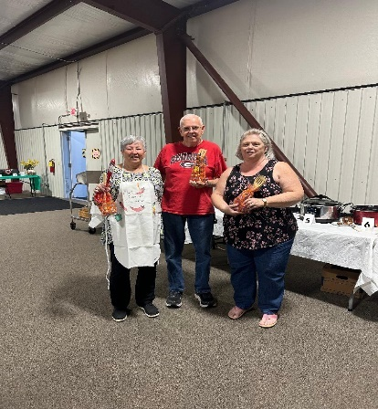
Adult Hay Ride 1st Place: Diane Gilbert
2nd Place: Morris Williams
3rd Place: Kim Fannin

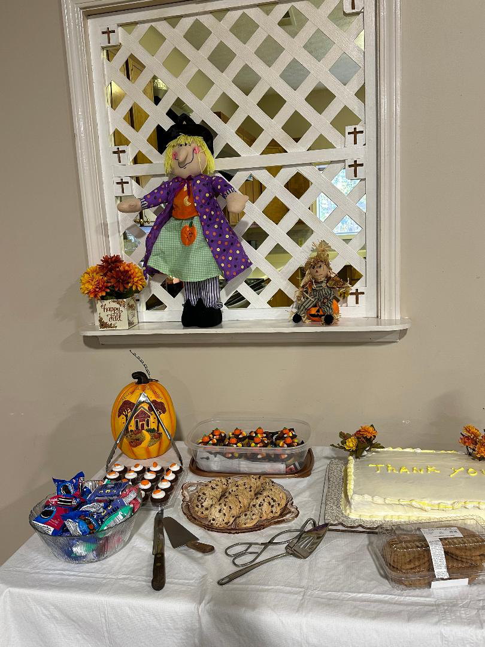
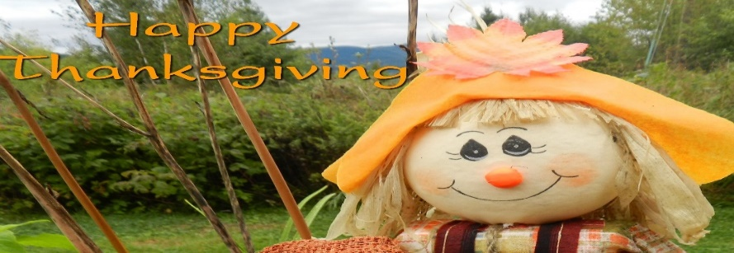November Events

Sunday | Monday | Tuesday | Wednesday | Thursday | Friday | Saturday
 |  |  | 1 | 2 | 3 | 4  Church Work Day  9 – 12N
 |  | 10-Women’s Bible Study  6:30 Bible Study  6:30- Bible Study | 7-Choir | 9-1- Busy Bee Sewing Bee (CH) |  | 9-12- Church Work Day  9-12- Quilters
5 | 6 | 7 | 8 | 9 | 10 | 11
10:30- Worship  All Saints’  Sunday |  | 10-Women’s Bible Study (CH) | 7-Choir | 9-1- Busy Bee Sewing Bee (CH)  7-9- Cumming Sunsetter Quilters (CH)
12 | 13 | 14 | 15 | 1 6 | 17 | 18
10:30-Worship | 10:00- Bake Cookies | 10-Women’s Bible Study (CH) | 7-Choir | 9-1- Busy Bee Sewing Bee (CH) |  | 9-Men’s Breakfast and Bible (CH)
19 | 2 0 | 21 | 22 | 23 | 24 | 25
10:30-Worship | 12:30-Women’s Group | 10-Women’s Bible Study (CH) | 7-Choir | 9-1- Busy Bee Sewing Bee (CH)  Happy  Thanksgiving
26 | 27 | 28 | 29 | 30
10:30- Worship | 10:00- Decorate for Christmas | 10-Women’s Bible Study (CH)  6:30-Advent Study | 7-Choir | 9-1 Busy Bee Sewing Be(CH)

