October 2023

Sharing the love of God through
Jesus Christ

LAITY SUNDAY, RECOGNITION AND STAFF APPRECIATION
Rise Up! is the theme of our service on Sunday, October 8th. Our Lay Leader, Mary Cheatham will lead the service that day as we recognize our laity and honor our staff.

Chili Cook-off
Ladies & Gentlemen, Get out your favorite chili recipe, make a crockpot to share and come to our chili cook-off on October 22 at 5 p.m. in the Fellowship Hall.

Clergy Appreciation Month and a “Basket of Love”
Each Sunday in October we will be collecting cards, gift cards, and other items to fill a basket for Pastor Dana. Think of an item you could add to our basket whether it is a personal note of appreciation, a gift card to a local restaurant or neighborhood store, or that special loaf of banana nut bread that you bake often for your family. We will present this basket to Pastor Dana on Sunday, October 22nd.Gail Bannon, Beth Blalock, and Barbara McNutt will collect your items on Sundays and add them to the basket. Any baked item brought on a Sunday prior to October 22nd will be delivered to Pastor Dana that day. The basket will be in Diane’s office; items can be left with her during the week.

C HARGE CONFERENCE UPDATE
We’ve been busy working on Charge Conference preparations, including leadership nominations, a budget, and administrative reports etc. Charge Conference for all the churches in our sub-district was originally scheduled for September 10. The date has now been moved back to Sunday, October 15, at 3:00 p.m. at St. Paul UMC Summit Street in Gainesville. Thanks to everyone’s hard work, we will be ready to approve our Charge Conference reports at our Council Meeting on Sunday, September 10 after worship and be finished!

Here is link to sign up to help out with making coffee and getting cookies/ doughnuts for after worship fellowship time.
signupgenius.com/go/4090448AEAC2FAB9-44572290-coffee#/

Silent Auction October 22-November 12
The Women of Pleasant Grove are bringing back the “Silent Auction” as their fundraiser for the 2023-24 year. Amy Faulkenberry is our treasurer; she will gladly accept any cash donations to support the group’s fundraiser. All money from the fundraiser goes directly to support the women’s ministry to our church and missions. Last year some of our projects included: Holiday Baskets to our Homebound members, personal care kits for the Women of Faith Ministry Outreach Project and a donation sent with Terra to Honduras for medical needs.

****************************************************************************
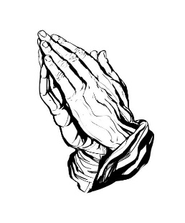 Prayer Line Is anyone among you in trouble? Let them pray. Is anyone happy? Let them sing songs of praise. 14 Is anyone among you sick? Let them call the elders of the church to pray over them and anoint them with oil in the name of the Lord. James 5:13-14
If you have a need for special prayer, please call or text Jennifer Wisniewski at 404-226-0023. If you would like to be on the prayer chain call Jennifer or the Church Office (770- 844-7095) and your name will be added to the list.
Calling Post, who sends out our prayer line messages, has recently changed the phone numbers the calls are being sent from. If you have any kind of call screening or blocking on your phone and you are having trouble getting prayer line messages, please add the following as safe numbers (405) 669-9959, (405) 669-9890 and (405) 669-9887.
*****************************************************************************

Birthdays & Anniversaries
Birthdays Anniversaries
October 4- Dorothy Cantrell October 17-Joe & Dawn Grella
October 8- Terra Manton October 27- Chris & Gail Bannon
October 11- Barbara Gilbert October 28- Richard & Brenda
Will Sacca Ashmore
October 12-Barbara Olson
October 13- Linda Walraven Liturgist
October 17- Kim Fannin October 1-Josh Sacca
October 18- Kurt Ross October 8- Wendi Jones
October 19- Terry Blalock October 15- Paul Cheatham
October 20- Marielle Sacca October 22- Luna Farris & Mary
October 21- Gavin Delaney Cheatham
October 24- Emily Garmon October 29- Amy Faulkenberry

Acolytes Greeter/Usher
October 1- Marielle Sacca October 1- Gavin & Darlene Delaney
October 8 -Lucas Restrepo October 8- Jane Martin & Kim Fannin October 15-Paige Restrepo October 15- Wesley Walraven & David October 22-Lucas Restrepo Smith
October 29- Elijah Banks October 22-Steve Massie & Terry
Holbrook
October 29-Morris Williams & Brandi
Banks

Counters
Linda Walraven Altar Guild
Terra Manton Mary Cheatham
Ruth Holbrook Darlene Delaney
Ruth Holbrook
October 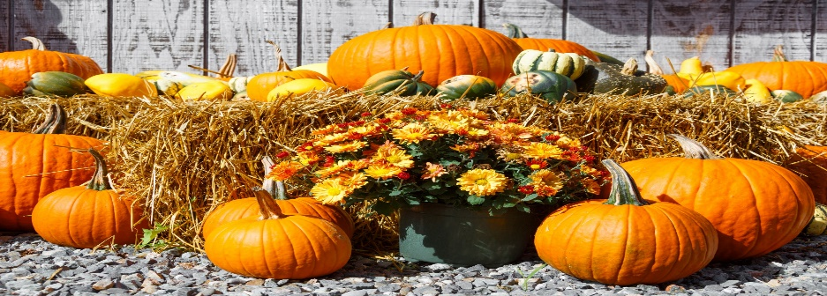

Sunday | Monday | Tuesday | Wednesday | Thursday | Friday | Saturday
1 | 2 | 3 | 4 | 5 | 6 | 7
 |  | 10-Women’s Bible Study  6:30 Bible Study  6:30- Bible Study | 7-Choir | 9-1- Busy Bee Sewing Bee (CH) |  | 9-12- Cumming Sunsetter Quilters (CH)
8 | 9 | 10 | 11 | 12 | 13 | 14
10:30- Worship |  | 10-Women’s Bible Study (CH)  6:30- Bible  Study | 7-Choir | 9-1- Busy Bee Sewing Bee (CH)  7-9- Cumming Sunsetter Quilters (CH) |  | Church Work Day  9-12
15 | 16 | 17 | 18 | 19 | 20 | 21
10:30-Worship  3:00 Charge Conference |  | 10-Women’s Bible Study (CH)  6:30 Bible Study | 7-Choir | 9-1- Busy Bee Sewing Bee (CH) |  | 9-Men’s Breakfast and Bible (CH)
22 | 23 | 24 | 25 | 26 | 27 | 28
10:30-Worship  5:00- Chili  Cook-off | 12:30-Women’s Group | 10-Women’s Bible Study (CH)  6:30- Bible Study | 7-Choir | 9-1- Busy Bee Sewing Bee (CH)
29 | 30 | 31
10:30- Worship |  | 10-Women’s Bible Study (CH)  6:30- Bible Study

