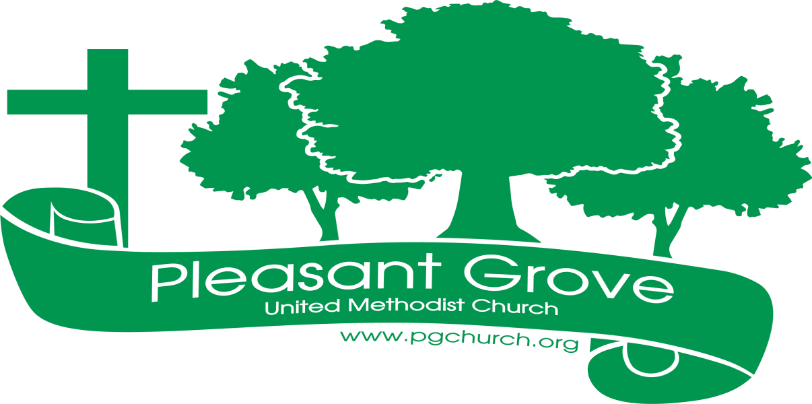
September 2023

Sharing the love of God through
Jesus Christ
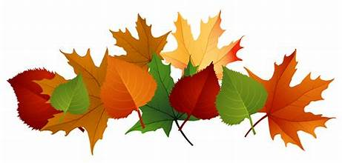 Fall Is Back!

NEW MEN’S GROUP!
Breakfast and the Bible will have its first meeting on Saturday, September 9, 9:00-10:00 a.m. in the Club House. Breakfast will be provided. For more information contact Josh Sacca or David Martin.

TUESDAY EVENING STUDY GROUP STARTS SEPTEMBER 12
Join us beginning Tuesday, Sept 12th at 6:30 p.m. in the Club House for a six-week study on Christianity and World Religions: Questions We Ask About Other Faiths by Adam Hamilton. Led by Pastor Dana, we’ll learn about the basics of other major faith traditions and compare them to our Christian faith so that we might grow in understanding others and come to a deeper appreciation of our own faith.

TUESDAY MORNING WOMEN’S BIBLE STUDY RESUMES SEPTEMBER 12
Our Women’s Bible Study resumes on Tuesday, September 12^{at} in the Club House. They’ll be doing a 12-week study titled “Twelve Women of the Bible.” Cost for the study book: $11.

UNITED WOMEN OF FAITH meet Monday, September 18 at 12:30 in the Club House.

CHARGE CONFERENCE UPDATE
We’ve been busy working on Charge Conference preparations, including leadership nominations, a budget, and administrative reports etc. Charge Conference for all the churches in our sub-district was originally scheduled for September 10. The date has now been moved back to Sunday, October 15, at 3:00 p.m. at St. Paul UMC Summit Street in Gainesville. Thanks to everyone’s hard work, we will be ready to approve our Charge Conference reports at our Council Meeting on Sunday, September 10 after worship and be finished!

COUNCIL MEETING, SUNDAY, SEPTEMBER 10
Our Church Council will meet immediately following worship on Sunday, September 10 in the Club House. The purpose of our meeting will be to approve Charge Conference reports and insurance.

LAITY SUNDAY, RECOGNITION AND STAFF APPRECIATION
Rise Up! is the theme of our service on Sunday, October 8th. Our Lay Leader, Mary Cheatham will lead the service that day as we recognize our laity and honor our staff.

CHILI COOK-OFF AND HAYRIDE COMING OCTOBER 22ND
Search for your favorite chili recipe and get it ready for our annual chili cook-off! More details coming soon.

ABOUT THE BIBLE series continues:
The New Testament
The New Testament books were written over a period of about 50 years (50-100 A.D.) They were written for several reasons: First, early Christians saw the need to preserve the memory of Jesus’ life and teachings. Second, as the number of Christians grew and spread throughout the region, it became important to provide instruction on the essentials of the Christian faith.
The New Testament writings were widely used in the years after they were written. We don’t know exactly when the various writings officially became part of the canon (BIble), but by 200 A.D. the Gospels and letters of Paul and several others were considered canonical. Some of the other writings varied for a while in terms of use and acceptance. The New Testament as we know it today was not in place until about 350 A.D.
— adapted from About the Bible by Terence Fretheim, p. 13

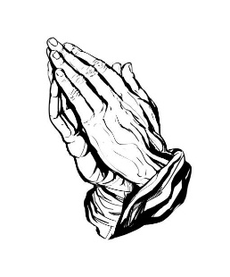 Prayer Line Is anyone among you in trouble? Let them pray. Is anyone happy? Let them sing songs of praise. 14 Is anyone among you sick? Let them call the elders of the church to pray over them and anoint them with oil in the name of the Lord. James 5:13-14
If you have a need for special prayer, please call or text Jennifer Wisniewski at 404-226-0023. If you would like to be on the prayer chain call Jennifer or the Church Office (770- 844-7095) and your name will be added to the list.
Calling Post, who sends out our prayer line messages, has recently changed the phone numbers the calls are being sent from. If you have any kind of call screening or blocking on your phone and you are having trouble getting prayer line messages, please add the following as safe numbers (405) 669-9959, (405) 669-9890 and (405) 669-9887.
*****************************************************************************
Birthdays & Anniversaries
Birthdays Anniversaries
September 1- Josh Sacca September 10- Don & Sandy Putnam
September 6- Mary Jones September 12- Kurt & Valeria Ross
September 9- Rex Tallant September 15- David & Jennifer
September 10- Barbara Croft Wisniewski
September 13- David Bradley September 27- Pat & Cindi Ripley
September 14- Kaylin Restrepo
September 21- Jean Massie
September 25- Ashlyn McGrady
September 27- Pat Ripley
September 28- Gene McBrayer
September 29- Brenda Ashmore
Steve Massie
September 30- Sandy Putnam

Acolytes Greeter/Usher
September 3- Lucas Restrepo September 3- Tammy McGrady & Seth
September 10-Paige Restrepo Steinberg
September 17- September 10-David & Pat Bradley

September 24- September 17- Morris Williams & Brandi
Banks Altar Guild-Barbara McNutt September 24- Steve Massie &
Luna Farris Terry Holbrook
September

Sunday | Monday | Tuesday | Wednesday | Thursday | Friday | Saturday
 |  |  |  |  | 1 | 2
 |  |  |  |  |  | 9-12- Cumming Sunsetter Quilters (CH)
3 | 4 | 5 | 6 | 7 | 8 | 9
10:30- Worship |  | 6:30-Finance Committee (CH) | 7-Choir | 9-1- Busy Bee Sewing Bee (CH)  7-9- Cumming Sunsetter Quilters (CH) |  | 9-Men’s Breakfast and Bible (CH)
10 | 11 | 12 | 13 | 14 | 15 | 16
10:30-Worship  Church Council Meeting |  | 10-Women’s Bible Study (CH)  6:30 Tuesday night Study | 7-Choir | 9-1- Busy Bee Sewing Bee (CH)
17 | 18 | 19 | 20 | 21 | 22 | 23
10:30-Worship | 12:30-United Women on Faith (CH) | 6:30- Bible Study | 7-Choir | 9-1- Busy Bee Sewing Bee (CH)
24 | 25 | 26 | 27 | 28 | 29 | 30
10:30- Worship |  | 6:30- Bible Study | 7-Choir | 9-1- Busy Bee Sewing Bee (CH)

