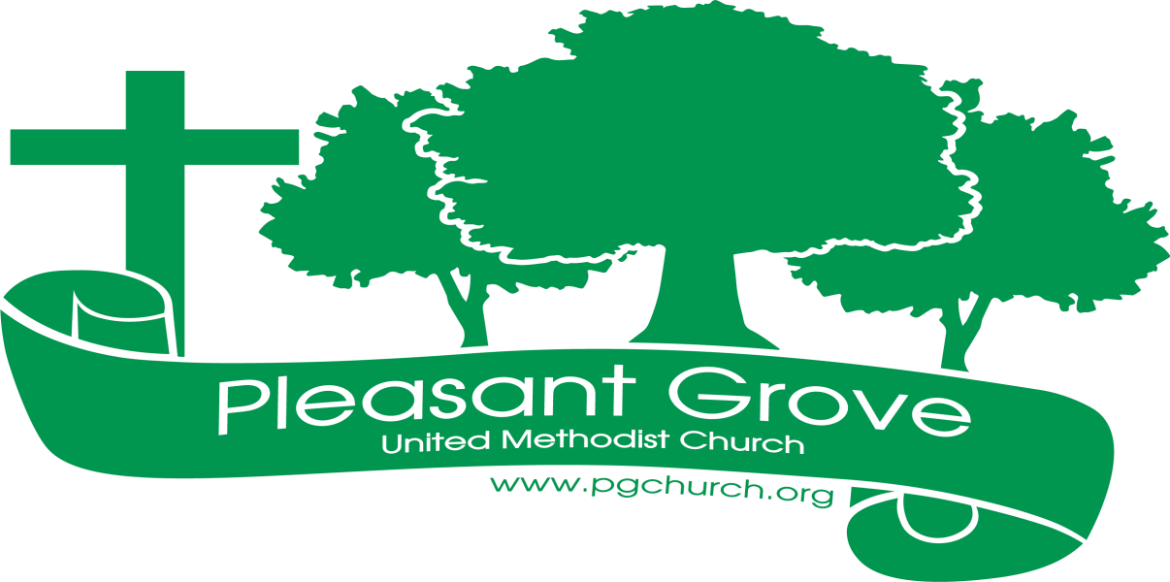
July 2023

Sharing the love of God through
Jesus Christ

What A Great Day for a Picnic!
Great food, fun and fellowship were had by all at our church picnic on Sunday, June 25th. We gathered first for worship (where shorts were allowed), and then headed over to Sawnee Mountain Park on a picnic perfect day. Following a wonderful meal that included but was not limited to the traditional picnic favorites such as hot dogs, chicken tenders, potato salad, baked beans, watermelon and pound cake, we enjoyed good conversation and a few games together. Thank you, Amy F for organizing this event!

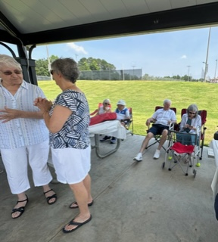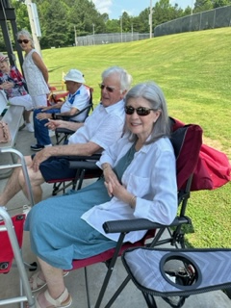
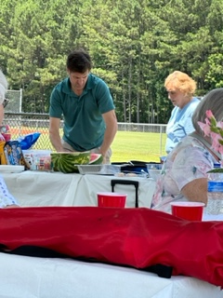

SUMMER MISSION PROJECT
Before we know it, it’ll be Back to School time in our community. To support the students in our neck of the woods, we’ll be collecting school supplies for the children at Sawnee Elementary School. Below are some suggestions of supplies you can purchase as you shop at the grocery store or big box store this month. There will be lots of sales going on! Bring your supplies and place them in the marked bin in the Welcome Center during the month of July.

*Water Color Paint Set, 8 colors, w/ brush
*Washable Markers, 8/set, Classic Colors, Wide-Tip
*Washable Glue Sticks, Purple, Dries Clear
*1 doz. #2 Pencils, Oriole, Sharpened, Latex-free
*6-Box Crayola Crayons, Tuck-Box
*Composition Book, Marble Color, Wide-Ruled, 100 sheets
*12-inch Ruler, Plastic, Inches and Centimeters, Center Holes
*24 Set Colored Pencils
*Stick Pens, Blue, Medium Point
*2 Large Erasers, Pink, Latex-free
*Filler Paper, Wide-rule, 100 pack
*Pencil Box, 8.25x5.25x2”

How Did Your Bible Grow?

The word “Bible’ comes from a Greek word that means “books.” The Bible is a collection of books, written by many different authors over the course of more than 1000 years. Another word used to refer to this collection of books is “canon.” The Bible is more than a collection of books, it’s a collection of books considered authoritative for the life and faith of Christians and the Church.
The Protestant Bible contains 66 books, but some church bodies include some additional books.
How did all these books come together to form the Bible? The Bible grew in stages over several centuries. Two phases can be identified in this gradual process: First, individual books were used by the Jewish and Christian communities for teaching and worship. As these books were used, they became increasingly authoritative. Second, at various times and places these books were officially recognized as canonical — that is, part of the Bible.
— adapted from About the Bible, Short Answers to Big Questions, pp.11-12, Terence E. Fretheim

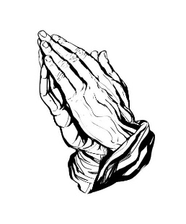 Prayer Line
Is anyone among you in trouble? Let them pray. Is anyone happy? Let them sing songs of praise. 14 Is anyone among you sick? Let them call the elders of the church to pray over them and anoint them with oil in the name of the Lord. James 5:13-14
If you have a need for special prayer, please call or text Jennifer Wisniewski at 404-226-0023. If you would like to be on the prayer chain call Jennifer or the Church Office (770- 844-7095) and your name will be added to the list.
Calling Post, who sends out our prayer line messages, has recently changed the phone numbers the calls are being sent from. If you have any kind of call screening or blocking on your phone and you are having trouble getting prayer line messages, please add the following as safe numbers (405) 669-9959, (405) 669-9890 and (405) 669-9887.

Birthdays & Anniversaries
Birthdays Anniversaries
July 1- Mary Cheatham July 10- Scott & Wendi Jones
Patience Wisniewski
July 3- David Wisniewski
July 15- Anita Knight
July 27- Sara McDaniel
Debra Williams
July 30- Adrianne Williams
Wesley Ross

Greeter/Usher
July 2- Wesley Walraven & David Smith
July 9- Steve Massie & Terry Holbrook
July 16- Seth Steinberg & Tammy McGrady
July 23- David & Pat Bradley
July 30- Morris Williams & Brandy Banks

Acolyte Altar Guild
July 2- Diane Gilbert Mary Cheatham & Ruth Holbrook
July 9- Kim Fannin
July 16-Tammy McGrady
July 23-Chris Bannon
July 30-Wendi Jones
We are back from another mission trip. As always, it was such a wonderful experience. It was so great after three years of my not going to see old friends and to meet new ones.

A busy week indeed. We arrived on Saturday afternoon and were greeted when we got off the ferry by many children and adults, holding signs welcoming us back. This so warmed our hearts. On Sunday we attended church services at Mizpah Methodist Church Utila. Since it was Father’s Day, the men of the church was in charge of the service. We then had lunch and, we doing medical, went back to our cabin and opened the many boxes we had packed and shipped in April, of medial supplies and medication and organized them. These were the supplies I was able to purchase with your generous donations , and those items you purchased for me to send.

The week went so swiftly. We medical visited the elderly and gave them bags of “goodies”, sang and prayed with them.

We did two clinics in the poorest of poor villages. One of the Honduran doctors and his nurse, who worked in the clinic we help, organized and we went with them. We saw 116 patients and gave them prescribed free medications.

During the week, we purchased groceries for 10 in need families. We, also visited a young adult girl who was born with spinal befida and was confined to a wheelchair. The wheelchair was rusty, almost impossible to roll. We left funds to purchase her a new one. It will be a while getting there, but when it does, she is going to be so
happy. Again, this was because of your generosity.

Others in our group did Vacation Bible School with the children. and our construction team worked on a building
that will house some of the teachers
that are employed at the Methodist School. We did not finish the building, but left funds to help complete it by the Hondurans that had worked for us during the week.

Too, team members, put fresh paint on some children tables and chairs and other structures at the school.

One morning, was spent going from class to class giving out bags to the children containing school supplies, along with soap, wash clothes, toothbrushes and tooth paste.

There are 188 children in the school most of which have a sponsor who lives in the US, because it is not a public school. Public schools only go to the 6th grade.

On Friday afternoon, we transported all the remaining medications from our cabin to the clinic there and I said my final, tearful, goodbyes. My plan is to still help the team that will be continuing our ministry there, but I want physically be going back. It has been a wonderful 26 years that I have been blessed to serve God and the wonderful Honduran people, but it is time to “pass the torch” and must follow what God has directed me to do.

Again, thank you, my church family and friends, for the support you have so lovingly and willing given me and our mission. We have accomplished so much because of you,

Blessings,

Terra
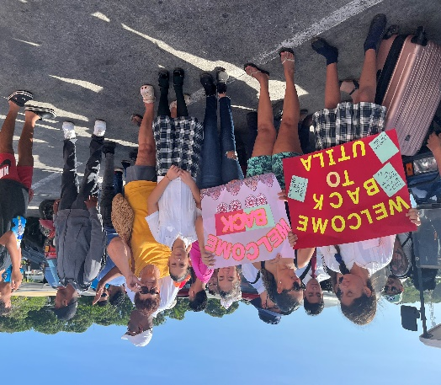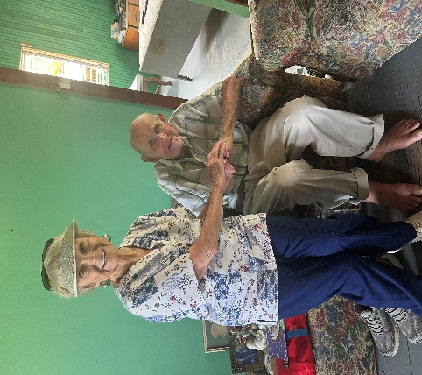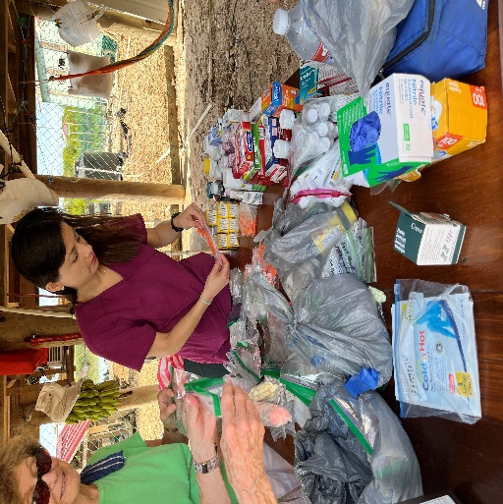

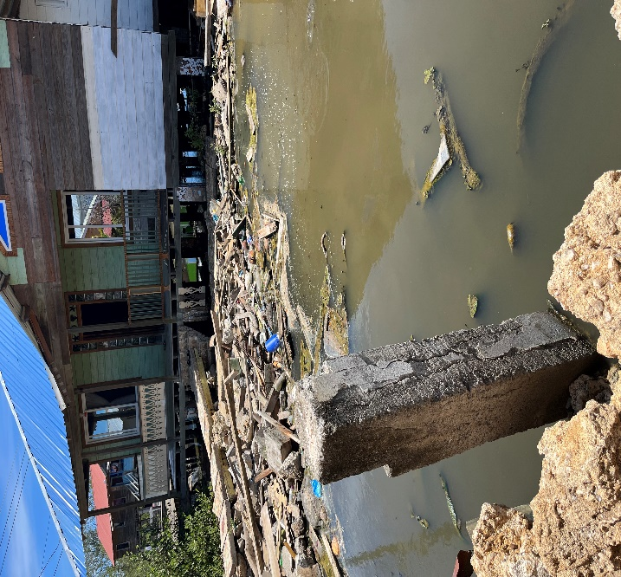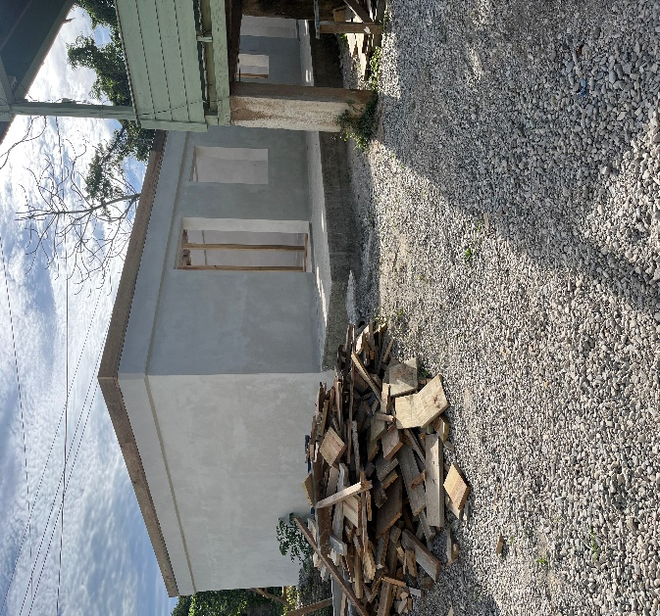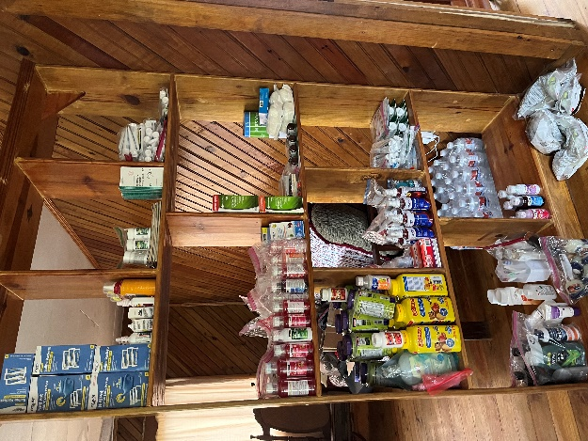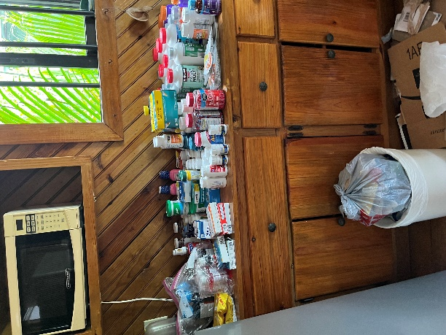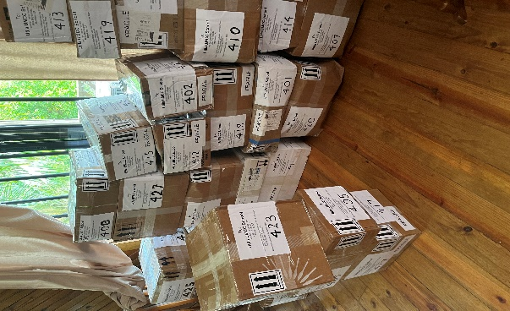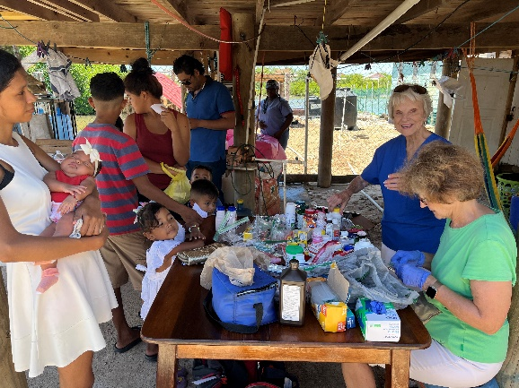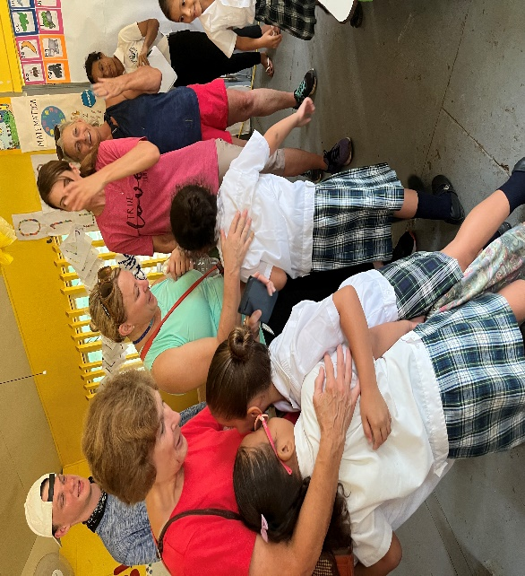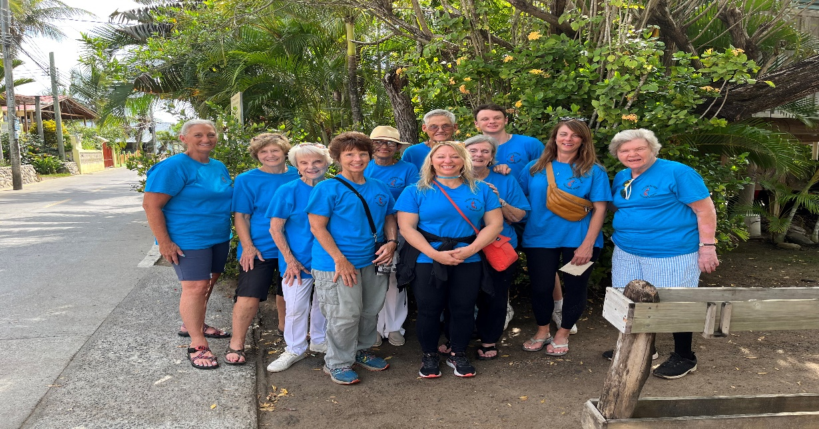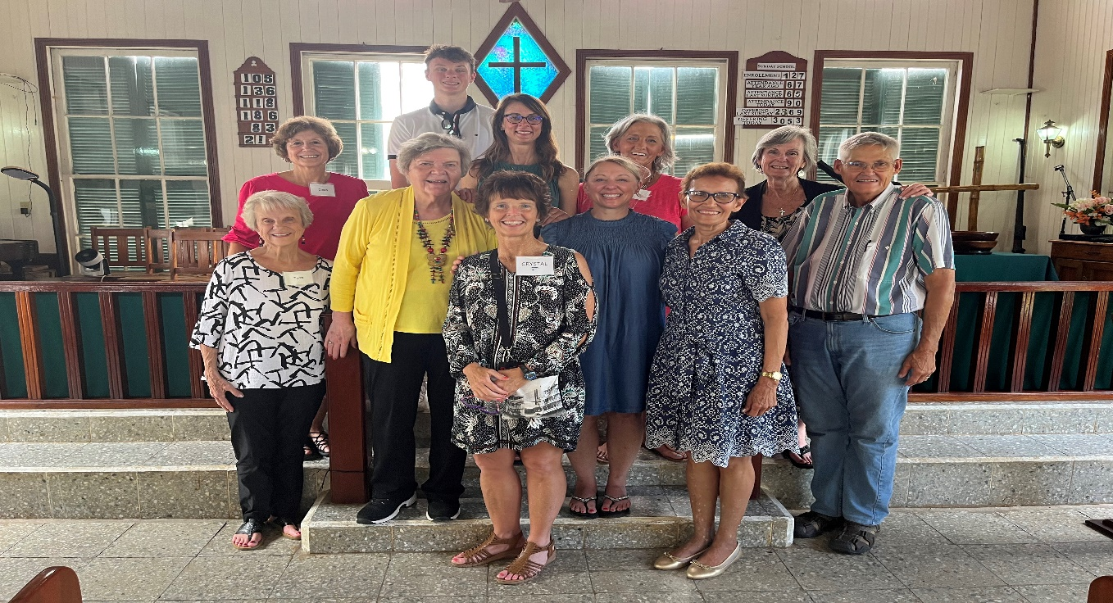

July

Sunday | Monday | Tuesday | Wednesday | Thursday | Friday | Saturday
 |  |  |  |  |  | 1
 |  |  |  |  |  | 9-12- Cumming Sunsetter Quilters (CH)
2 | 3 | 4 | 5 | 6 | 7 | 8
10:30- Worship |  |  | 7-Choir | 9-1- Busy Bee Sewing Bee (CH)  7-9- Cumming Sunsetter Quilters (CH)
9 | 10 | 11 | 12 | 13 | 14 | 15
10:30-Worship |  | 6:30- Sizzling Summer Bible  Study | 7-Choir | 9-1- Busy Bee Sewing Bee (CH)
16 | 17 | 18 | 19 | 20 | 21 | 22
10:30-Worship |  |  | 7-Choir | 9-1- Busy Bee Sewing Bee (CH)
23 | 24 | 25 | 26 | 2 7 | 28 | 29
10:30- Worship  -----------------  30  10:30- Worship |  | 6:30- Sizzling Summer Bible Study | 7-Choir | 9-1- Busy Bee Sewing Bee (CH)

