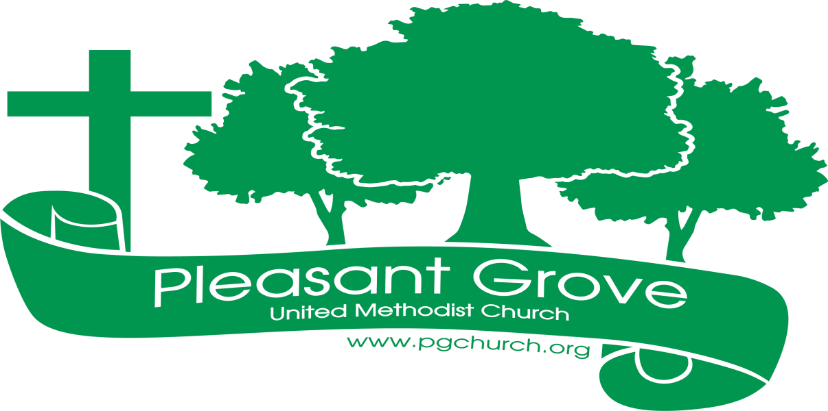
May

Sharing the love of God through
Jesus Christ

HOMECOMING
May 7th at 10:30 a.m.
Join us for worship, fellowship, and food on Homecoming Sunday, May 7th at 10:30 a.m. We will have lunch after the service in the Fellowship Hall.

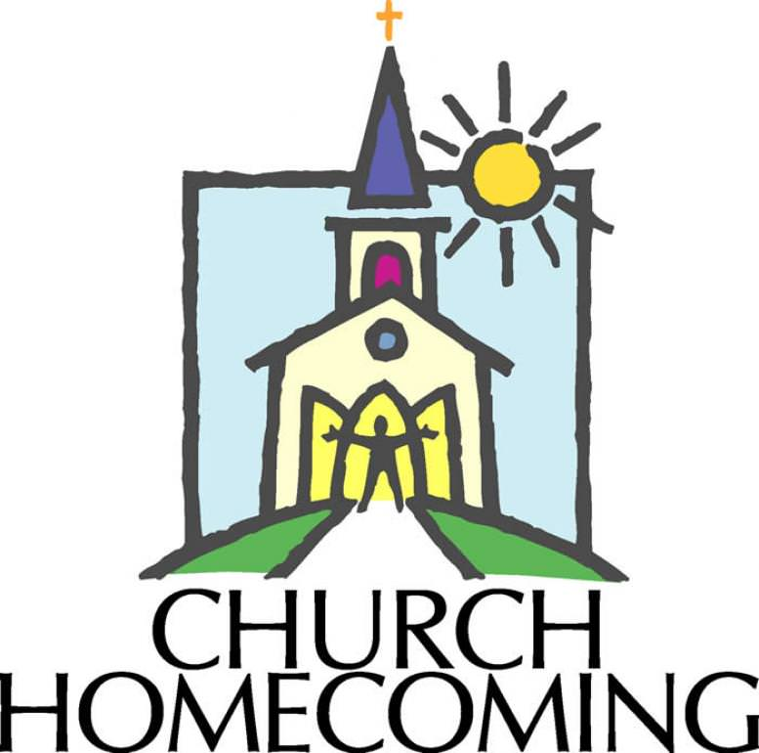

Graduate Sunday May 14
Congratulations!!! We are proud of you!
Members Graduating High School Members Graduating College
Isabella Sacca Tori Ross
Cary Bannon
Kaylin Restrepo
Members of Our Church Family Graduating
Mary Grace Manton- Granddaughter of Terra Manton
Logan Knight- Grandson of Joe & Anita Knight

***************************************************************************************************
ANNUAL CONFERENCE 2023
Pastor Dana and Lay Delegate Barbara McNutt will be attending and representing Pleasant Grove at Annual Conference in Athens, June 1-3.

COMING THIS SUMMER
Another Sizzlin’ Summer Study: Come when you can and come as you are for Bible study and prayer led by Pastor Dana. Details coming soon!
We’ll be having a couple of summer fellowship gatherings. Stay tuned for details.
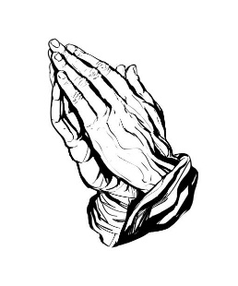 Prayer Line
Is anyone among you in trouble? Let them pray. Is anyone happy? Let them sing songs of praise. 14 Is anyone among you sick? Let them call the elders of the church to pray over them and anoint them with oil in the name of the Lord. James 5:13-14
If you have a need for special prayer, please call or text Jennifer Wisniewski at 404-226-0023. If you would like to be on the prayer chain call Jennifer or the Church Office (770- 844-7095) and your name will be added to the list.
Calling Post, who sends out our prayer line messages, has recently changed the phone numbers the calls are being sent from. If you have any kind of call screening or blocking on your phone and you are having trouble getting prayer line messages, please add the following as safe numbers (405) 669-9959, (405) 669-9890 and (405) 669-9887.

Birthdays & Anniversaries
Birthdays Anniversary
May 7- Steve Schimweg May- 23- Steve & Angela Schimweg
May 13- Jennifer Sacca
May 14- Emma McMillan
May 18- Jason Murphy
May 19- Katie Wallace
May 21-Cameron Wisniewski
May 23- Dianna Tribble
May 25- Sam Ellis
May 28- Sheryl Cline
May 29 – Lauren Ripley
Jacqui Sherman
May 31- Allison Ellis

Liturgist, Acolyte, Usher
May 7- Liturgist-Don Putnam May 28- Liturgist-Chris Bannon
Greeter/Usher- Wesley Walraven & David Smith Greeter/Usher- Gavin & Darlene
Acolyte- Lucas Restrepo Delaney
Acolyte- Lucas Restrepo
May 14- Liturgist-Diane Gilbert
Greeter/Usher- Terry Holbrook & Steve Massie
Acolyte- Paige Restrepo

May 21- Liturgist-Josh Sacca
Greeter/Usher- Jane Martin & Amy Faulkenberry
Acolyte- Marielle Sacca
May Activities 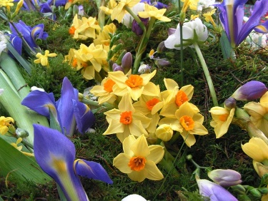
Sunday | Monday | Tuesday | Wednesday | Thursday | Friday | Saturday
 | 1 | 2 | 3 | 4 | 5 | 6
 |  |  | 7-Choir | 9-1- Busy Bee Sewing Bee (CH) |  | 9-12- Cumming Sunsetter Quilters (CH)
7 | 8 | 9 | 10 | 11 | 12 | 13
10:30- Worship-  Homecoming  Lunch afterwards |  | 6:00  Sandra Barker  Piano Recital | 7-Choir | 9-1- Busy Bee Sewing Bee (CH)  7-9- Cumming Sunsetter Quilters (CH)
14 | 15 | 16 | 17 | 18 | 19 | 20
10:30-Worship  Graduate Sunday  Happy  Mother’s Day |  |  | 7-Choir | 9-1- Busy Bee Sewing Bee (CH)
21 | 22 | 23 | 24 | 25 | 26 | 27
10:30-Worship | 12:30- United Women in Faith |  | 7-Choir | 9-1- Busy Bee Sewing Bee (CH)
28 | 29 | 30 | 31
10:30- Worship |  |  | 7-Choir

