April Ambassador 2023
Sharing the love of God through
Jesus Christ
___________________________________________________________
HOLY WEEK

Palm Sunday - April 2 - 10:30 a.m.
Holy Thursday – April 6 - 7 p.m.
Good Friday – April 7 - 7 p.m.
Sunrise Service – Sunday- April 9 - 7 a.m.
Easter Worship – April 9 - 10:30 a.m.

Prayer Line
Is anyone among you in trouble? Let them pray. Is anyone happy? Let them sing songs of praise. 14 Is anyone among you sick? Let them call the elders of the church to pray over them and anoint them with oil in the name of the Lord. James 5:13-14
If you have a need for special prayer, please call or text Jennifer Wisniewski at 404-226-0023. If you would like to be on the prayer chain call Jennifer or the Church Office (770- 844-7095) and your name will be added to the list.
Calling Post, who sends out our prayer line messages, has recently changed the phone numbers the calls are being sent from. If you have any kind of call screening or blocking on your phone and you are having trouble getting prayer line messages, please add the following as safe numbers (405) 669-9959, (405) 669-9890 and (405) 669-9887.

Birthdays & Anniversaries
Birthdays Anniversaries
April 9- Sam Ellis April 1- Josh & Jennifer Sacca
April 14- Delaney Lyle April 3- John & Allison Ellis
April 15- Mitchell Martin April 4 –Joe & Kim Fannin
April 18- Sarunya Dye
April 20- Doris Holbrook
Monica Wigley
April 26 -GG (Gwyn) McCormick
April 28- Toni Smith
April 29- Glennell Holbrook
Dawn Grella

Liturgist, Acolyte, Usher
April 2- Liturgist- Don Putnam April 23-Liturgist- Barbara McNutt
Acolyte- Lucas Restrepo Acolyte- Paige Restrepo
Ushers- Wesley Walraven & Jane Martin Ushers- Kim Fannin & Ruth Holbrook

April 9- Liturgist- Diane Gilbert April 30- Amy Fulkenberry
Acolyte- Paige Restrepo Acolyte- Lucas Restrepo
Ushers- David & Pat Bradley Ushers- Tammy McGrady &
Seth Steinberg
April 16- Liturgist- Josh Sacca
Acolyte- Mariell Sacca
Ushers- Steve & Jean Massie
April Activities
This Photo by Unknown Author is licensed under CC BY
Sun |  | Mon |  | Tue |  | Wed |  | Thu |  | Fri |  | Sat
1
Cumming Sunset Quilters 9-12 CH
2 Palm/Passion  Sunday  Worship-10:30  Walraven Family Luncheon-12-2 (FH)  Girl Scouts-3-5 (CH) |  | 3 |  | 4  Bible Study- 11:00 (CH) & 6:30 |  | 5  6:30- Choir |  | 6  Busy Bees Sewing Bee -9-1 (CH)  7-Holy Thursday |  | 7  7- Good Friday Service |  | 8
9 Easter  7 am-Sunrise Easter Service  Easter Celebration-10:30 |  | 10 |  | 11  Bible Study  9-12 |  | 12  6:30- Choir |  | 13  Busy Bees Sewing Bee -9-1 (CH)  Cumming Sunset Quilters- 7-9 (CH) |  | 14 |  | 15
16  Worship-10:30  Girl Scouts-3-5 (CH) |  | 17  12:30-United Women of Faith  (CH) |  | 18  Bible Study  9-12 |  | 19  6:30- Choir |  | 20  Busy Bees Sewing Bee -9-1 (CH) |  | 21 |  | 22  Baby Shower (CH)
23  Worship-10:30 |  | 24 |  | 25  Bible Study  9-12 |  | 26  6:30- Choir |  | 27  Busy Bees Sewing Bee -9-1 (CH) |  | 28 |  | 29
30
Worship-10:30

Girl Scouts-3-5 (CH)
Spiritual Life Retreat Weekend at Camp Glisson

Another wonderful SLR weekend with our youth group is in the books. A little rainy upon arrival on Friday, but lots of sunshine Saturday and Sunday. Definitely the coldest SLR weekend I can remember, though.

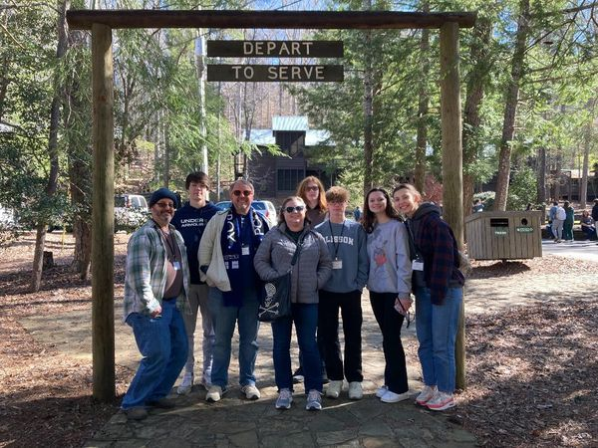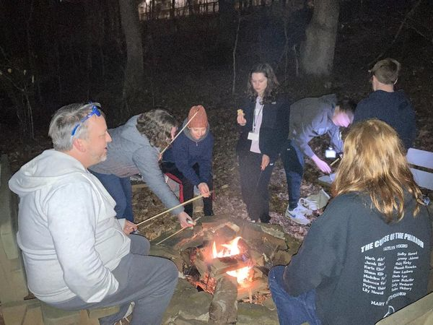
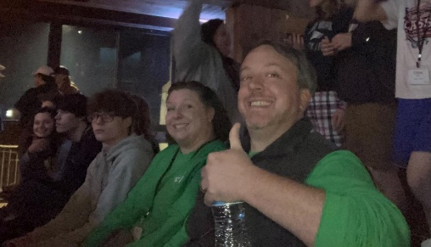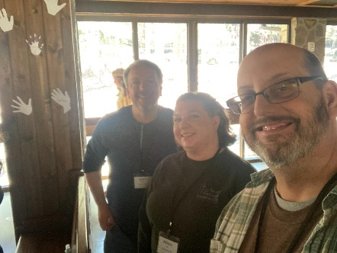

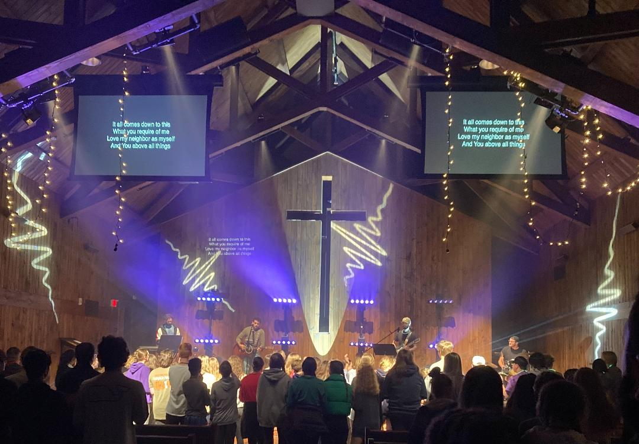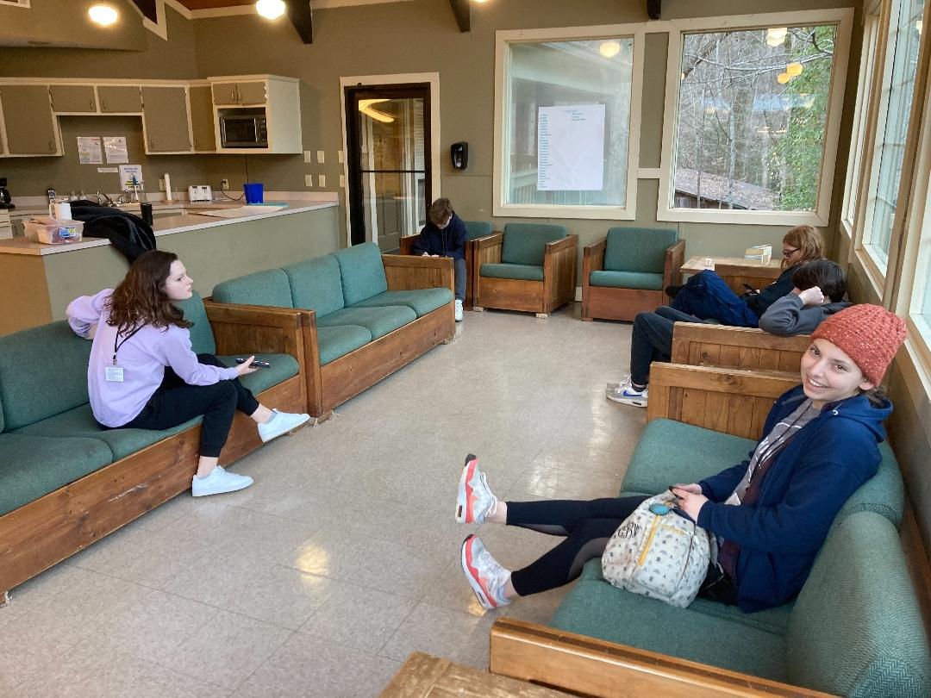

A Note from the Bishop
Pastor Garrett,
Thank you and the Pleasant Grove Congregation on paying 100% apportionments. I am grateful for your commitment to the Connection .
Grace & Peace,
Bishop Dease
*****************************************************************************************************************
Pastor Dana,
Thank you so much for the love and support you provided to mom and our family the past few weeks. Your presence brought a sense of calm to the room. The funeral service was perfect and beautifully presented. Please share with the congregation, our family’s thanks for the love and support they provided to mom over the years.
Sincerely,
Susan Dare & the Jackson Family
*****************************************************************************************************************
Homecoming

Join us for worship service on Homecoming Sunday, May 7th at 10:30 a.m. We will have lunch after the service in the Fellowship Hall. A sign-up sheet will appear later for you to sign up to bring your favorite homecoming dish/dishes.

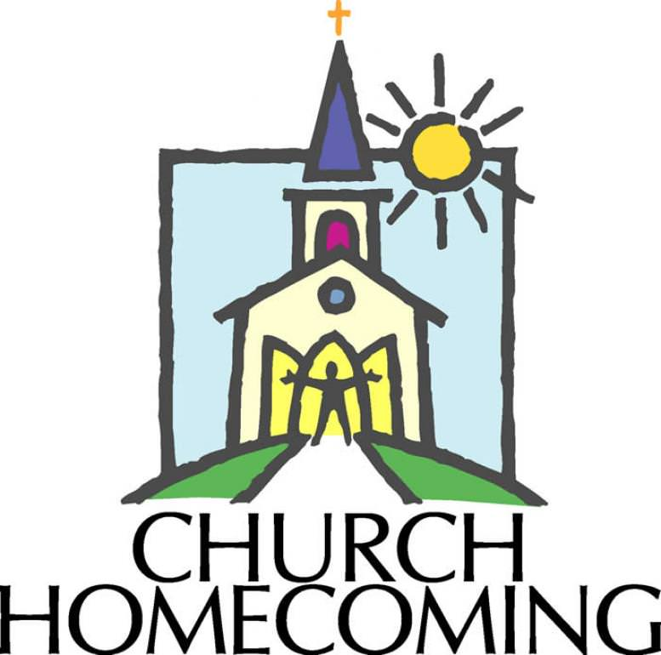
Spring Work Day ….

