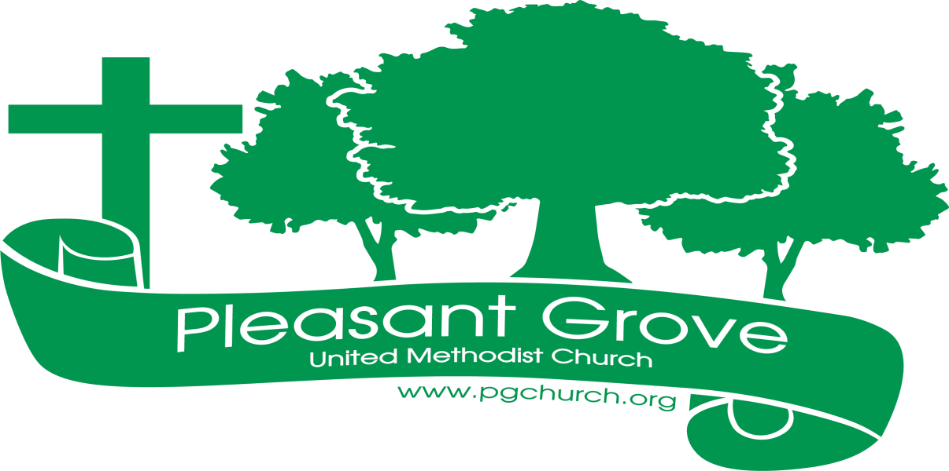
March
Ambassador 2023

Sharing the love of God through
Jesus Christ
____________________________________________________________
FROM THE PASTOR
Our church leaders met one Saturday morning in February for a follow-up meeting to our recent recent Leadership Summit. I opened the meeting with a devotional on Proverbs 29:18a, “Where there is no vision the people perish…” (KJV)
One of the things we learned at the Summit is that congregations go through life cycles. If they do not renew their vision with the changing times they will eventually die. Having celebrated Pleasant Grove’s past with its 150th anniversary, it’s time to look toward Pleasant Grove’s future and cast a new 21st century vision. Our community has been changing rapidly. New people have been moving in by the thousands, bringing their perspectives, cultures, hopes, dreams and needs with them. As the Church we are called by Jesus himself to “Go and make disciples.” Jesus did it by going out and meeting people as they were and inviting them to “Come and see.” That‘s what we must do.
One of the essential, vital elements for a bright future for Pleasant Grove is growing our Welcome, Invitation and Visibility in our community. Here are some things you can do to help us grow our welcome, invitation and visibility:
*Personally welcome guests who visit on Sunday morning. Learn and remember their first name. Be sure to thank them for coming and invite them back.
*Invite people in your circle of contacts for worship AND other events like Bible study, fellowship groups, United Women in Faith, choir, etc.
*Help us be more visible in the community by participating in local hands-on service projects.
*Refer people to our website or Facebook page. (We have contact cards to help you do that.)
*Write a review for our church on Google Maps. Like us on Facebook. Share about your church on your social media apps.
*Wear your Pleasant Grove t-shirt!

These are just some of the ways we can live into our 21st century vision for Pleasant Grove and fulfill our mission of “Sharing the love of God through Jesus Christ.”
Grace and Peace!
Pastor Dana

LEADERSHIP SUMMIT UPDATE: TURNING IDEAS INTO ACTIONS!
Sixteen leaders of Pleasant Grove gathered for the Leadership Summit follow-up meeting on Saturday morning, February 22. Our purpose was to turn some ministry ideas inspired at our Leadership Summit on January 29 into actions for ministry in our church and community. Our ideas focused on 4 areas essential for the vision and future of Pleasant Grove with both easy and challenging action items and leaders to champion each in 2023:
Improving our Welcome, Invitation and Visibility, including Multi-Generational Families:
- Action: Put Welcome Packets back in the pew racks
Champions: Amy F. and Barbara M. (Done!)
- Action: Update PGUMC on Google Maps and ask people to write
positive reviews about our church
Champion: Josh S.
- Action: Start a Saturday morning Breakfast and the Bible group
Champions: David M. and Josh S.
- Action: Update PGUMC contact cards to hand out
Champion: Pastor Dana
Establishing Missional Partnerships to expand sustainable ministry:
- Action: Sing at eldercare facilities in our community
Lay Champion: Chris B.
- Action: Partner with Sawnee Elementary School
Champions: Jennifer W. and Mary C.
Increasing Lay Confidence and Courage in owning ministry and decision-making:
- Action: Engage persons watching our live online worship
Lay Champion: Jennifer and Marielle S.
- Action: Begin Council Meetings with intentional spiritual formation
Champion: Pastor Dana
- Action: Start a Prayer Group on Zoom
Champion: Jennifer W.
Strengthening Our Financial House:
- Action: Contact families, send acknowledgements when special donations made to the church
Champions: Paul C. and Beth B.
- Action: Publish weekly giving amount and monthly giving/expenses for congregation
Champion: Kim F.
- Action: Arrange for someone to speak each quarter during worship on giving
Champion: David M.
This is just THE beginning! Champions will report back to our Church Council on March 12 and update us on where they are in turning these ideas into actions in 2023.

You are invited to observe a holy Lent…

2nd Sunday in Lent, March 5, 10:30am Blessed to Be a Blessing
3rd Sunday in Lent, March 12, 10:30am The Wilderness of Sin
4th Sunday in Lent, March 19, 10:30am Don’t Get Distracted
5th Sunday in Lent, March 26, 10:30am Dem Bones!
Palm/Passion Sunday, April 2, 10:30am Rounding the Corner
Holy Thursday, April 6, 7:00pm Such a Sacrifice
Good Friday, April 7, 7:00pm The Passion of Christ

ANNOUNCEMENTS

MISSION PROJECT FOR LENT
Collecting Coins for UMCOR (United Methodist Committee on Relief, the disaster relief agency of the UMC). Each family may pick up a Lenten Coin Calendar and coin box in the Welcome Center. You can follow the calendar and give coins each day, or spare change as it comes in, or make on donation with bills or a check. We'll turn in our donations on Easter Sunday.

YOUTH GROUP HEADING TO SLR
Our youth group is heading to their annual Spiritual Life Retreat at Camp Glisson March 17-19. The weekend features worship and small groups, a block party and the ever popular duck races!

CHURCH COUNCIL MEETING
Sunday, March 12th at 5:00 in the Club House.

SPRING WORK DAY, MARCH 25
Our Trustees have scheduled a Spring Work Day for Saturday, March 25th, 9:00am-12N. There will be indoor and outdoor projects for just about everybody to pitch in and help. We want you to participate! We'll have coffee, juice, donuts and water to sustain you.

Honduras Outreach

“Do all the good you can, By all the means you can, In all the ways you can, In all the places you can, At all the times you can, To all the people you can, As long as ever you can” John Wesley
Again, I am returning to Honduras. We are traveling on June 17, 2023. Many know, because of my neck injury I was unable to go last June with the team. However, I had already purchased medical supplies and medications with the money given to me by my church family and friends.
In April, we had packed and shipped them and other, VBS and construction supplies. Two team members trucked the boxes to New Orleans port and they were put on a ship to Honduras. (It takes about 6-8 weeks for them to be transported and unloaded.). They were there when the team arrived.
With the money given to me after shipment, I purchased last minute request and a team member took them in a piece of luggage. Also, money to buy food for the very poor. Unfortunately, if you made your check out to the church, because of privacy of church members, I was not given the name or the amount of those that were so gracious to support our ministry. That was the reason you did not get a thank you note nor receipts, as you have in the past, on what I purchased with your generous donation.
Saturday, we had a team meeting, and we decided to again purchase early,
pack and again ship before the team goes. This has worked well the last two years. This method is easier than having to deal with each of the team having so many pieces of luggage to be responsible, and a chance it might not get there. We will be shipping the last of March or early April.
A list of most needed items is included. As in the past I will be happy to purchase for you, and send you a receipt. In order to do this, please make your check out to me.
My heart is full of gratitude and just a big Thank You for you support.

Blessings, Terra

Medical supplies and over-the-counter medications
(generics are fine)

Tylenol (acetaminophen) Tooth paste
Cough syrup for adults and children Medical tape
Antiseptic throat spray Hydrocortisone cream
Cough drops Neosporin
Nasal spray Triple antibiotic ointment
Aspirin 81 mg. Vitamins: Children, prenatal, adults,
Ibuprofen for adults and children 50 plus
Aleve
Ranitidine tablets
Tums Cold and flu medication for adults and
Children
Allergy for adults and children
Benedryl for adults and children
Ear wax removal kits
Ace bandages any size width
Disposable examination gloves
Medium and large
Disposable N-95 mask
Tooth brushes, adult and child

Prayer Line

Is anyone among you in trouble? Let them pray.
Is anyone happy? Let them sing songs of praise. 14
Is anyone among you sick? Let them call the elders of the
church to pray over them and anoint them with oil in the name of the Lord. James 5:13-14

If you have a need for special prayer, please call or text Jennifer Wisniewski at 404-226-0023.
If you would like to be on the prayer chain call Jennifer or the Church Office (770- 844-7095) and your name will be added to the list.

Calling Post, who sends out our prayer line messages, has recently changed the phone numbers the calls are being sent from. If you have any kind of call screening or blocking on your phone and you are having trouble getting prayer line messages, please add the following as safe numbers (405) 669-9959, (405) 669-9890 and (405) 669-9887.

Birthdays & Anniversaries
Birthdays Anniversaries
March 1- John Ellis March 4-David & Pat Bradley
March 5-James Bannon March 29-John & Amy Faulkenberry
March 7- Luna Farris
March 9-Gail Bannon
Mary Mc Brayer
March 14-Jeff Holbrook
March 17- Richard Ashmore
March 25- Margaret Tribble
March 26- David Holladay
March 29- John Faulkenberry

Missions
SOCKS AND UNDIES SUNDAYS UPDATE!
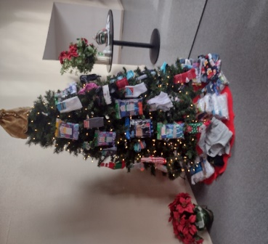
Once again Socks and Undies Sundays were a big success. We collected well over 200 pairs of socks and undies that were donated to Family Haven. Family Haven provides resources, safe temporary shelter, crisis support, and referral services for victims of domestic violence. They were thrilled with the donation as the socks and undies were something they were in great need of.

SOUPER BOWL SUNDAY
On Super Bowl Sunday, ya’ll generously brought cans of soup to church with you before heading home to watch the Eagles and the Chiefs battle it out. Because of you, we were able to donate over 100 cans of soup to The Place. The Place was founded in 1975 by four Dominican Nuns. The sisters offered assistance with financial needs, clothing, shelter, food, and even tutoring. Today, The Place continues to assist people in Forsyth and Dawson county with essential needs and helps them to be self-sustaining.
UMCOR
Originally founded in 1940 in response to displaced and vulnerable populations in the wake of World War II, The United Methodist Committee on Relief (UMCOR) is a ministry of The United Methodist Church through the General Board of Global Ministries. Their goal is to assist the most vulnerable people affected by crisis or chronic need without regard to their race, religion, gender, or sexual orientation.
Through the season of Lent, we will be collecting for UMCOR. You will find coin collection boxes and calendars on a table in the Welcome Center.
In His service – Jennifer Wisniewski
March
Calendar Events
Sunday | Monday | Tuesday | Wednesday | Thursday | Friday | Saturday
 |  |  | 1 | 2 | 3 | 4
 |  |  | Choir- 6:30 (S) | Quilting—9-1 (CH)
5 | 6 | 7 | 8 | 9 | 10 | 11
Worship-10:30 (s)  Girl Scouts-3-5 |  | Lent Study-11 (CH)  Lent Study-6:30  (CH) | Choir- 6:30 (S) | Quilting—9-1 (CH)
12 | 13 | 14 | 15 | 16 | 17 | 18
Worship-10:30 (s)  Church council-5 pm (CH) |  | Lent Study-9:30 (CH)  Lent Study-6:30  (CH) | Choir- 6:30 (S) | Quilting—9-1 (CH)
19 | 20 | 21 | 22 | 23 | 24 | 25
Worship-10:30 (s)  Girl Scouts-3-5 (CH) | 12:30- United Women of Faith  (CH) | Lent Study-11 (CH)  Lent Study-6:30 (CH) | 7-Ash Wednesday Service (S) | Quilting—9-1 (CH) |  | 9-12-Church Work Day
26 | 27 | 28 | 29 | 30 | 31
Worship-10:30 (s) |  | Lent Study-11  (CH)  Lent Study-6:30  (CH) | Choir- 6:30 (S) | Quilting—9-1 (CH)
(CH)- Denotes Club House
(S)- Denotes Sanctuary
(FH)- Denotes Fellowship Hall

Ban
March Schedule for Liturgist, Acolyte & Greeter/Usher

March 5
Liturgist: Mary Cheatham
Acolyte: Marielle Sacca
Greeter/Usher: Ruth Holbrook & Kim Fannin

March 12
Liturgist: Paul Cheatham
Acolyte: Lucas Restrepo
Greeter/Usher: David Smith & Wesley Walraven

March 19
Liturgist: Jennifer Wisniewski
Acolyte: Paige Restrepo
Greeter/Usher: Seth Steinberg & Tammy McGrady

March 26
Liturgist: Chris Bannon
Acolyte: Marielle Sacca
Greeter/Usher: Gavin & Darlene Delaney

